A plenum is merely a sealing device, a way to ensure air is not bypassing the engine entirely. You and I have seen lots of leaky flap seals, and some that were an outright joke.
There have indeed been serious efforts to measure flap seal leakage. The best known is probably NASA CR3405. They measured total mass flow for the stock Aztec installation (think typical GA less-than-perfect flap seals) and a sealed plenum:
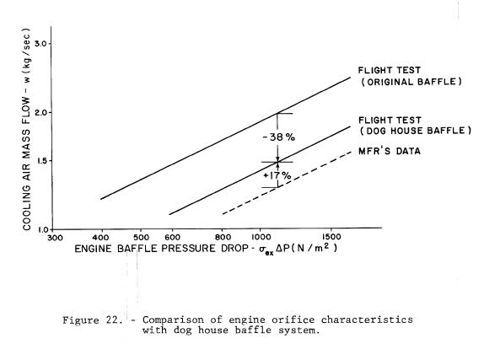
They found approximately 38% of the inlet air was doing nothing useful, and even the sheetmetal doghouse they put together for the test didn't seal well enough to match Lycoming cooling chart data. Obviously a really well-sealed plenum is better than a leaky plenum, which is better than leaky flap seals.
Ahhh, but we've also seen flap seal installations which were outright artistry, beautiful exhibits of craftsmanship which clearly suffered minimal leakage. Is a plenum better than those? My guess is probably not......but I've not had a chance to instrument one of them.
The practical question in the field is how to judge sealing quality. CR3405 offers a clue; they measured outlet air temperature for the two configurations:
Flow temperature measurements made directly below the engine and at the cooling flow exit showed a significant reduction, and suggested the mixing of heated and unheated cooling air, lending support to the leakage theory.
Air following a leak path doesn't pick up as much heat as air passing between cooling fins. Leaky baffles exhibit low exit temperatures.
Nothing says you can't cool with leaky sealing. You can, and you can see it done with most of the Cherokees and such parked on any ramp. You just need to run a lot more mass through the system to compensate for the leakage and low pressure differential....and the extra mass flow (x momentum loss) makes the airplane slower.

