Jet-A For the Rest of Us
The Continental Diesel RV-10
Dan Horton - November 2017
_____________________________________________________________________________________
Scott Flandermeyer is a patient man.
Roll the clock back to 2008. A booming US economy had a taken a hit following the Wall Street subprime meltdown, and fuel prices dived with it, driven by reduced demand. By December, wholesale avgas was under $2 per gallon, rosy news indeed for pilots who had the means to fly. But then, like the stock market, fuel prices rebounded.
Flandermeyer had begun a Vans RV-10 kit in 2008. By mid-2010, about the time he began to think about an engine choice, a $6 sign on an avgas pump wasn't unusual in Atlanta. Jet-A was about a dollar less, so it didn't take much to turn his attention to the talk of new diesels. After all, he burned Jet-A by the ton in his day job at Delta.
The possibilities were limited; only DeltaHawk and SMA appeared to have suitable engines. DeltaHawk's two-stroke diesel V-4 was a nice fit in terms of weight and size, but produced little more than the bare minimum power for an RV-10. At that time, DeltaHawk had a few pre-production engines out with potential military and OEM customers, but was telling everyone EAB applications would have to wait.
The French SMA opposed four was much farther along the development curve, having received both EASA and FAA certification by 2002. The SR305-230 had already been installed in a variety of aircraft, most notably as a popular Cessna 182 retrofit. So, Flandermeyer gave SMA a call. The US sales representative was encouraging, but after consulting the home office, the eventual answer was "No". Although SMA representatives had indicated the engine was available to homebuilders (at Airventure 2008), in reality it seems they wanted the participation of kit manufacturers, not an individual effort.
There was one last possibility. In the spring of 2010, Continental had entered into a licensing agreement with SMA. CEO Rhett Ross was firmly committed to transforming the company into a world-wide supplier of engines, and outside the US, that meant Jet-A. Now rising 100LL prices added a potential US market. Buying technology from SMA was a way to begin their own development from an advanced position, rather than starting from scratch, and enter the market years sooner.
Licensing put Continental in the game, but there was no Jet-A product available, not yet. For Flandermeyer, it was a long shot, but he called anyway, and kept calling every few months. Today he laughs, and says "They just never told me to go away." Eventually he found himself talking to engineers Mike Gifford and Johnny Doo. They were open-minded, and kept asking questions. "How would you do this?" was the common theme. Doo gave him a draft copy of the manual. "Here, proofread this for us. Tell me what you think." They talked a lot, a steady two-way exchange.
In reality, Flandermeyer's timing was near perfect. Teledyne sold Continental to AVIC of China in the spring of 2011, accelerating the company's focus on non-avgas development. Then they bought the assets of the Thielert bankruptcy in 2013, adding the Mercedes-based CD-135 and CD-155 geared diesels to the product line. Suddenly Continental was the world leader in Jet-A piston engines, with committed management at every level, and Flandermeyer was in the door.
Still, progress was slow. With new a corporate owner, new business divisions, and new cash, Continental had a lot of organizing to do. The water-cooled CD-135/155 program went to the front of the line; there were a large body of engines already in the field, and OEM interest at Cessna for what became the Skyhawk JT-A. The Thielert buy came with a water cooled V-6 diesel too. Both the Mercedes-based V-6 and the SMA-based air/oil cooled flat four were targeted for certification, with teams on both sides of the Atlantic. Flandermeyer heard "Next quarter" repeatedly, but he stuck.
Finally, in late 2015, he got a diesel. The engineers had made a lot of changes along the way, so many that the improved 230 horsepower Continental (which the type certificate calls a TD-300-C) was no longer the end product. The new goal was 265 horsepower for fixed wing applications, which would again stretch the calendar. However, since certification required a demonstration of the production process, the factory had built a batch of CD-230 parts. Some of the resulting engines went to the test cell for verification. Others were used to run prototype parts for the 265. A few were quietly distributed to interested parties...and one homebuilder.
Flandermeyer's experimental CD-230 came with a formal contract. He would follow the factory's operational dictates to the letter, doing maintenance as directed and supplying a constant stream of data. Disclosure to outside parties would require approval. Ownership of the engine would remain with Continental, because if deemed successful in the RV-10, it would be a mere stand-in for the real purchase, a production CD-265 to be delivered later. In the meantime, Flandermeyer would be both installation engineer and test pilot, with a little help where needed. He was delighted, and set to work.
The Nitty-Gritty Shop Stuff
The first task was the design of a motor mount, which required a careful analysis of weight and balance. The CD-230 looks a lot like any other flat four, but has massive rotating and reciprocating components compared to an avgas engine of similar displacement. The core weighs about 450 lbs, including the primary exhaust and turbocharger, but without the air-to-air induction intercooler, the high pressure induction plumbing, or the very large oil cooler. In comparison, the RV-10's typical IO-540 has a core weight of roughly 400 lbs with induction and starter.
Most builders gravitate to a lightweight propeller when confronted with extra engine mass, but diesel prop options are limited. As a rule-o-thumb, combustion pressures are about three times higher. When combined with a low cylinder count, it means the prop must deal with very high oscillating torque. The prop hub and blade roots must be significantly larger for the same power level, and blade vibration analysis is critical. MT and Hartzell had each developed a propeller for the SMA diesel, and either could be flown on the CD-230. Flandermeyer selected the less pricy MT, which weighs 65 lbs. In comparison, a typical MT for a gas 540 is about 40 lbs, plus spinner.
The MT hub incorporates a significant extension, which pushes the engine mass rearward to a position roughly equal to the rearmost four cylinders on the 540. The heavy accessories (turbo, intercooler, and oil cooler) are also toward the rear. A battery is behind the baggage compartment, and as the CD230 requires 24V to crank, that battery would be a Concorde RG24-16 at nearly 30 lbs. In the end, the prop stayed in the same place, and airframe CG was not greatly impacted.
An acquaintance recommended a structural engineer to design the motor mount. The FAA had issued special certification guidance for the Cessna Skylane diesel program which required higher margins for torsional strength; specifically 4x mean torque as compared to 2x for a gas engine. Following those guidelines seemed sensible. Although beefy, the finished motor mount structure did not require any crazy geometry.
Flandermeyer was able to measure and pattern a set of engine baffles taken from an SMA engine, which just happened to be removed from its airframe at the time. Friends at the airline shop helped with stout brackets and fittings. Aero engineers interested in the project quietly offered advice and drawings. Serendipity ran rampant. It seemed as if every time a challenge arose, he immediately stumbled across the right people.
There are three fuel pumps, an electric Andair to deliver fuel from the tanks, an engine-driven rotary pump, and the high pressure injection pump. Fuel filters were re-located to the wing roots, so cleaning them doesn't cause a Jet-A smell in the cabin. There are no water separators. The fuel system returns roughly 40 GPH to the tanks, so it requires 3/8" return lines, plus a duplex fuel selector to route the fuel back to the source tank. It's possible to plumb the fuel return directly back to the engine, but doing so requires a fuel cooler. Flandermeyer installed both a tank return system and a fuel cooler, as specified by the manuals, although the factory engineers are satisfied that wet wing metal tanks shed more than enough heat to the airstream (they're more concerned with water freezing in the fuel at altitude). N104ST's system is instrumented, and so far fuel inlet temperature has gone no higher than 105F during an Atlanta summer (max is 149F). The fuel itself is strictly Jet-A or similar, never diesel fuel, as highway diesel can't meet certification requirements. Flandermeyer adds Biobore, a popular anti-microbial.
Accurate fuel flow instrumentation has been a challenge. Earlier CD-230 B and C models used a computer and servo to control the injection pump; the cockpit fuel flow indication is derived from the computer's fuel map, not an actual measurement. For simplicity, Continental eliminated the computer and servo during CD-265 development; the cockpit power lever is connected directly to the injection pump. That's also true of Flandermeyer's experimental engine. Right now the system uses a pair of Electronics International "red cube" FT-60 turbine senders (one in, one return), but significant pressure pulsation in the diesel's fuel flow makes them inaccurate.
It's safe to call the CD230 and CD-265 "oil cooled engines", as they shed about 2/3 of their waste heat via a dedicated oil system with its own pump, separate from the lube flow. The required heat exchanger is huge by conventional standards. An off-the-shelf unit from the Cessna STC wouldn't fit, so Pacific Oil Cooler built a custom unit, which was plumbed in series with a normal sized cooler to meet the total capacity requirement. The cooling oil flow rate (15 gallons per minute) requires -12 lines. The auxiliary cooler was ducted to provide cabin heat, as the oil system is always above 150F in flight. Pacific built the air-to-air intercooler too. The oil itself is full synthetic, currently an experimental Phillips 10-40 obtained via Continental, along with an equally experimental Tempest filter. Synthetics work very well, as there is no tetraethyl lead in Jet-A.
Sharp-eyed readers may noticed an electric preheat system. The absolute lowest allowable oil temperature is 20F, and anyway, a cold diesel can be hard to start. It saves time too, as the manuals require 150F oil temperature and less than 130 psi before advancing above 1500 RPM.
The cowl required a lot of modification, and likely will require more. The obvious difference is a pair of oil cooler and intercooler inlets at lower left and right. Both connect to internal fiberglass ducts, which expand to the area of their respective heat exchangers. The intercooler seems to be doing fine, but oil temperature currently limits climb. Calculations showed the lower left inlet to be much too small, so it and its ductwork is scheduled for surgery at the next annual.
Resizing the conventional air inlets by the spinner resulted in little change to cylinder head temperatures, not surprising since they are heavily oil cooled. The cylinder barrels, however, are entirely air cooled. Thermocouples on the barrels may allow reshaping much of the nose. Currently all three cooling flows (air-to-air, oil, and cylinder baffle) exit the cowling in a conventional manner at the bottom of the firewall. Flandermeyer installed a pair of electric cowl flaps, which do help tailor flow between climb and cruise.
The diesel brought one bonus to the installation; a painless exhaust installation. The primary exhaust connecting the cylinder heads to the turbocharger is a critical component. Builders installing the typical gas 540 six-cylinder must purchase or fabricate an entire exhaust system, but Continental supplies the turbodiesel with everything but the single tailpipe.
Let's Go Fly
The primary engine controls are simple. A diesel has no throttle plate. Instead the cockpit power lever is connected to the CD-230’s injection pump; power varies in proportion to delivered fuel. A mechanical stop prevents the pilot from inadvertently moving the fuel control to idle cutoff. RPM is controlled by an MT governor driven from the forward end of the camshaft. As a practical matter, N104ST's prop lever is used to exercise the 3-blade before departure, and is then parked at the full forward stop until the next flight. In the air, the CD-230 B and C always run at 2200 RPM. The CD-265 will offer 2200 to 2500. There is no mixture control.
Diesels typically incorporate a cold-start glow plug system, fundamentally an electrically heated rod extending just a wee bit into each combustion chamber. The installed Bosch system is fully automatic. When armed with a panel switch, it looks at OAT and decides how long to heat before turning off an indicator light, after which the pilot need only turn the key. Typical glow time is about 7 seconds at 32F. As a compression ignition engine, it starts even better hot (instantly) than cold (pretty darn quick).
The engine unquestionably sounds like a diesel at idle, a pleasant rumble. If the sound and feel isn't enough, 31" Hg of manifold pressure at 1000 RPM says things will be different on this flight. With an OAT around 70F, we reach the 150F minimum oil sump temperature required for full throttle by the time we taxi to the end of KFFC's Runway 31.
This particular experimental diesel is a mix of standard CD-230 production parts, some CD-265 parts, and a sprinkling of prototype parts under test. As a test mule, there is no calibrated stop on the power lever. Instead, power is set by consulting a compressor inlet temperature vs altitude chart to determine an acceptable manifold pressure. The limit is an eye-popping 95" Hg at high air density (for example, at SL, and below freezing), while Standard Day SL conditions call for 91". At 70F and 800 MSL, Flandermeyer pushes in about 86" and starts rolling while the engine and turbo reach equilibrium, then adjusts for 87" as we climb past 2000 at 1250 FPM.
Margaritaville beckons, but schedules don't allow a long cruise today. We settle in at 4500, under the Atlanta Class B. Pulling the power to 70" results in 155 KTAS. CHTs quickly drop to the 300F range, with a turbine inlet temperature of 1025F, far lower than typical for a comparable turbocharged avgas engine. The fuel flow indication is useless, oscillating between 8 and the low 9's. However, Flandermeyer says we're at 70%, and if true, we don't need a fuel flow meter. Diesels are lean burn IC engines, and as such, exhibit a consistent BSFC at any power setting. This engine's BSFC is about 0.360, so assuming 70% of 230HP and Jet-A at 6.84 lbs/gal, we're burning about 8.5 GPH, not bad for a cabin airplane down low in the thick air. It's worth remembering that the CD-230/265 will produce 70% all the way up into the oxygen altitudes, where the RV-10 will go a lot faster.
Descent can be tricky. The CD series is restricted to a minimum in-flight manifold pressure, below which compression ignition may not light the fire. The manual currently requires 45" Hg when OAT is less than 30F, no less than 30" Hg under any circumstances, and a minimum CHT of 212F. Carrying power is complicated by the diesel prop, which maintains a lot of pitch even when against the blade stops. The combination works fine for a cruise descent at 150 to 160 KIAS, resulting in about 1000 FPM. However, slowing up for the pattern requires patience. The 10 is slippery, and the coarse pitch offers little braking effect. Flandermeyer nurses the throttle back to around 34" on downwind, then 31" on final. The diesel doesn't seem to care (we're in warm, thick air), but CHTs are below 230 as we coast out, on a 70F afternoon.
Eye On The Prize
N104ST is an experimental project in the true sense of the word, a new application with a learning curve for all concerned. The goal is to expose issues and fix them, so future users can install and fly with minimal effort. With 80 hours clocked, the punch list has been remarkably short.
Early on, the installation developed more EGT split than desired, so a Continental team swapped out the injection pump and injectors. It may not have been strictly necessary, but it allowed returning the original pump to Mobile for inspection, a training opportunity for all.

Every oil change includes analysis at Blackstone; the airplane is grounded until the results are known. One sample got lost in the mail, a fine example of unanticipated aggravation (it turned up a few weeks later). The oil coolers alone hold nearly five quarts, and the big one has its own drain. However, there is no separate fill port, so a complete change requires filling the sump, then running the engine until the vernatherm valve opens (which refills the coolers), then refilling the sump. It’s a bit risky (the sump level drops dramatically when the valve opens), so for now the team is simply draining the sump every 25 hours without draining the coolers, roughly equal to a complete change every 50 hours. The big cooler may get its own a fill port.
Flandermeyer 's number one developmental goal is weight loss. Vans Aircraft publishes an RV-10 empty weight of 1600 lbs, but the Vans demonstrators are famously spartan. Most RV-10's fall into a range between 1675 and 1750 lbs, as owners tend toward leather interiors, loaded panels, and air conditioning. N104ST tips the scales at 1917 lbs empty, which is portly, but the excess isn't strictly due to the engine itself. The avionics are extensive, and more than one cow contributed to passenger comfort. The SafeAir1 extended range fuel tanks add 7.5 gallons per side at a cost of 15 lbs. A stock Vans cowl is about 21 lbs, but 104ST's cowl is a cut-and-try prototype, full of extra glass and filler. It weighs a whopping 37 lbs, plus the internal glass ductwork for the coolers on both sides, and may get even heavier with the next cut-and-try.
Going forward, the cowl and ducts will probably change to carbon with the CD-265 install. Hartzell's "Next Gen" foam core carbon blade should be significantly lighter, as compared to the MT's wood core; a spokesman says they are committed to the CD-265. Replacing the lead-acid main battery with a pair of EarthX LiFePo4 batteries in series will chop another 20 lbs. An additional 18 lbs of aux batteries (ensuring electrons for IFR with the all-glass panel) are also subject to change. Still, it's impossible to eliminate the entire diesel weight penalty. Compared to a parallel valve 540, the core engine and required coolers total as much as 80 extra pounds. The near term goal is 1850 empty.
As you see it here, full main tanks (60 gallons of Jet-A), two standard humans, and 35 lbs of baggage puts N104ST at the Vans-specified gross of 2700 lbs. Flandermeyer considers minimum fuel to be 5 per side, leaving 50 useable. Cruise fuel burn at 90% (which is perfectly fine) works out to be a fuzz less than 11 GPH, or 4 hours plus a VFR reserve, plus the captain's 10 gallons. The full 90% (207 HP) is available to around 13,000 feet, where true airspeeds are high. Fill the aux tanks, load a pilot and 100 lbs of gear, pull the power back to 55%, and endurance becomes more than 10 hours with a VFR reserve.
Continental is dead serious about piston Jet-A. Fuel cost, fuel availability, and remarkable fuel efficiency are the driving forces in a world market CMG intends to lead. Scott Flandermeyer, on the other hand, did not intend to lead the EAB world into a diesel future. He just wanted an efficient RV-10. Although it will require more work (and dollars) to reach the ultimate goal, Scott clearly remains fascinated. When you're having fun, efficiency is merely a bonus.

SIDEBAR ---- CD-265 Specifications
Scott Flandermeyer is currently flying a hybrid built with CD-230, CD-265, and prototype parts, but it won't be on his RV-10 forever. Eventually N104ST will sport a new CD-265, and we'll go back then for a serious look at in-flight performance. For now, imagine 260+ HP to nearly 10K, then cruising at 235 HP on less than 12 gallons an hour.... ___________________________________________________________________________________
Model per Type Certificate: TDIO-304-A
Bore and Stroke: 4.995 x 3.937 inches
Displacement: 303.64 cubic inches
Compression Ratio; 15:1
Maximum Altitude: 20,000 ft
Maximum Continuous Power: 262 HP @ 2500 RPM
Recommended Cruise: 235 HP
Max RPM / Idle RPM: 2500 / 800
Fuel Requirement: Jet-A, Jet-A1, Jet Fuel No.3, TS-1
Consumption at 262 HP: 81-88 lbs/hr
Consumption at 235 HP: 71-78 lbs/hr

SIDEBAR ---- INSIDE THE CONTINENTAL CD-265
After seven years of development, the Continental CD-265 (fixed wing) and CD-285R (rotorcraft) share very few parts with their distant SMA ancestor. The pistons, connecting rods, crankcase, cylinders, cylinder heads, head gaskets, tension studs, oil pump assembly, sump casting, primary exhaust, turbocharger, injection lines, and intake manifold are new… and it’s not the entire list. We visited Mobile for an inside look.

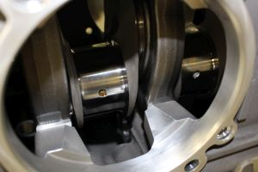
There are five main bearings supporting four massive crank throws. Main bearing carriers are forged steel (dark material), clamped between aluminum case halves. An all-aluminum case would not be strong enough, while an all-steel case would be too heavy. An oil passage feeding a nozzle in the bearing carrier (barely visible here at about 7 o-clock) sprays cooling oil at the underside of the piston.

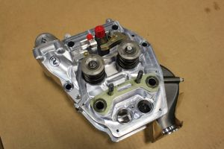
CD-265 cylinder heads are CNC machined from aluminum billets, rather than castings. Every surface is machined, including the ports. Valve layout is conventional, with pushrods and rockers. Here the aluminum intake spigot is at upper left, and the gray steel exhaust manifold stub is at lower right. Steel plates (one shown here, in light green) support the ends of the clamp studs.
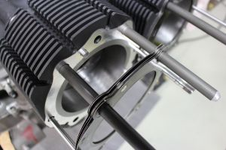
Head and barrel are separate parts, with a multi-leaf metal head gasket. The finned barrel is aluminum with a pressed-in iron liner. In this photo the clamp studs have been replaced with assembly jig rods.
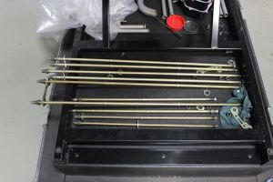
Six one-piece studs extend from cylinder head to the opposite cylinder head, all the way through the case and crankshaft supports. Four shorter studs extend from cylinder head to the outside face of the opposite case, at the most front and rear positions. Long stud length provides consistent clamp pressure across a wide range of operating conditions. They're carefully tensioned at assembly (pre-torque, then torque to angle) to provide a high level of fatigue resistance. In addition, two small diameter studs at 3 and 9 clamp each head to its barrel.
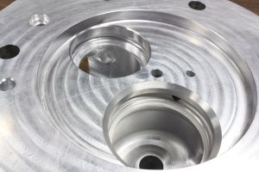
Oil cooling circuits are separate from the lube oil system, sharing only the sump. Most of the oil volume is circulated to the heads. The valve seats are oil cooled; note the annular grooves machined into the valve seat openings. When the steel valve seat ring is shrunk into place, the machined grooves form an oil passage behind the seat. The relatively cool seat boosts heat transfer from the hot valve when closed, extending valve life.
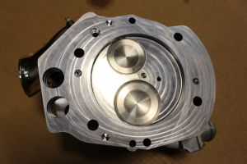
Combustion chambers are flat-topped. In this view you see six stud passages, four oil passages (for separate lube and cooling circuits), two dowel pin bores, and the pushrod tube openings. Fuel injector tip is near the center of the chamber, between the valves, with the glow plug tip to its right.
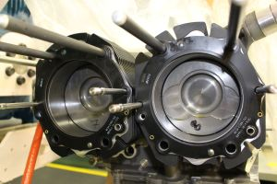
Most of the 'combustion chamber" is a recess in the top of the piston, again typical for a diesel. These particular pistons are experimental, not production.

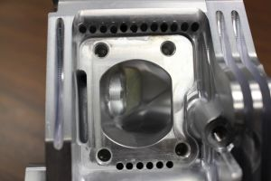
Drillings on each side of the exhaust port remove material to reduce heat transfer to the head. More heat energy remains in the exhaust stream, where it can be utilized by the turbocharger.
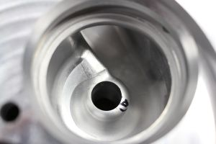
The fully machined intake port is shaped to maximize combustion chamber swirl velocity, critical for clean diesel combustion.
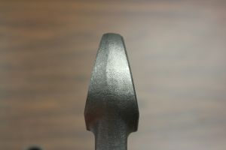
The wrist pin end of the connecting rod is pyramidal. Tension load is much less than compression load, and it allows additional supporting material in the piston crown.
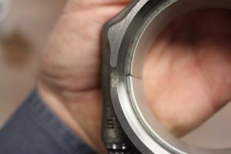
Connecting rod big end, with the conventional two-piece bearing shell in place. The rod is manufactured as a single piece, then the rod caps are fractured away from the main body in a controlled process. When re-assembled and clamped, the resulting fracture seam is so fine that it is practically invisible to the naked eye. Look close.
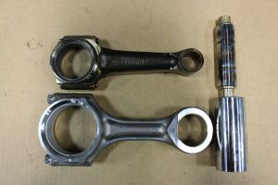
Gasoline IO-360 connecting rod and piston pin at top, CD-265 rod and pin at the bottom. Although engine displacement is 15% less than the gas engine (360 cubic inches vs 304 cubic inches), combustion pressure is roughly 3x higher, so the piston, pin, rod and crank are all massive in comparison. For example, compare the piston pin diameters, and the rod journal diameters, which are 2.125" vs 2.75"
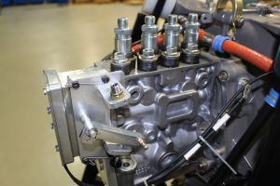
The fuel injection is old-school P-L-N; the modified Bosch P7100 distribution pump seen here pushes metered fuel through hard steel lines to mechanical injection nozzles. A mechanical system doesn't support the injection tricks possible with electronic control, but it is robust, requires no electrical power, and is understood by mechanics worldwide. The CD-265 has no electronics, other than those required for glow plugs and instruments.
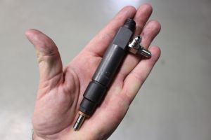
Classic mechanical injection nozzle. High pressure supply pulse lifts a spring-loaded check valve off its seat, allowing fuel to squirt through fine holes in the nozzle, which protrudes slightly into the combustion chamber. A small quantity of bleed fuel is returned to the tank or supply pump via the port on the side.
DH

PHOTO CAPTIONS Credits: Scott Flandermeyer, Dan Horton
lead photo
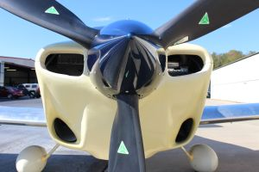
Lower inlets feed the oil cooler and air-to-air intercooler
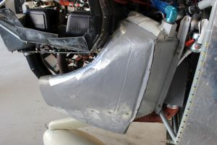
Huge primary oil cooler holds nearly five quarts. The sump holds eight more.
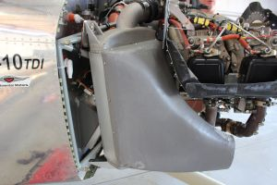
Hot compressed air from turbocharger passes through this large intercooler, then to intake manifold.
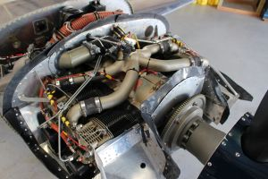
Flat four layout is conventional for GA, but every detail is different.
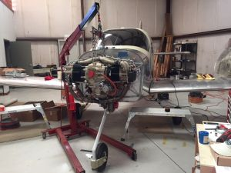
It took a long time to get to this point, but once started, the installation went quickly.

