I really have no idea on how the whole plenum - cooling system works. It is hard for me to understand how small leaks would make that much of a difference.

Here is a results-based tutorial. The three graphs plot actual measured performance from an earlier version of my own cooling experiments, and an early version of an ongoing effort by another builder. 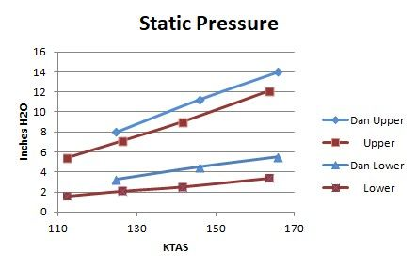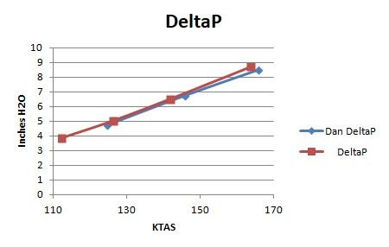
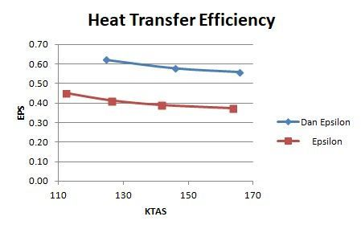
On top we have upper and lower static pressure. Your goal here is to design for the maximum conversion of available dynamic pressure (a function of airspeed and density) to static pressure in the upper cowl volume. Maximizing upper deck pressure improves everything about the system. I have previously suggested 0.8 as a reasonable conversion, but you can do better.
Lower cowl pressure is mostly a function of outlet area. Big outlet = low pressure, small outlet = high pressure.
The middle chart is DeltaP, the pressure difference between the upper and lower cowl volumes. This is what drives air through the fins...or through the leaks, a path that picks up no heat. Although the pressure is small in familiar terms (the charted max of 8.5" H2O = 0.3 psi), it typically pushes two to four pounds of air through the fins and leaks per second.
Look back at the first chart. The blue cowl had higher upper deck pressure, so the exit was made smaller, and thus lower cowl pressure is also higher. Now back to chart two; the result is essentially the same DeltaP for both cowls. That means both cowls flow air at the same rate. However, greater lower cowl pressure means the blue cowl will exhibit higher exit velocity. Cooling drag is mass x loss of momentum. Both cowls are flowing the same mass, but the blue cowl has less loss of momentum, so (all other things being equal) it will be a faster airplane.
Let us consider leakage, either through badly fitting baffle wraps, or a badly fitted or fastened plenum, or past good 'ole flap seals. Titan's Bobby Looper once told us dyno studies showed one square inch of leakage area results in a one inch H2O loss of DeltaP. Less DeltaP means less mass flows through the fins. The hit is two-fold. Less mass though the fins means less cooling, plus mass flowing through the leaks and on through the cowl without picking up heat contributes only drag...remember "mass x loss of momentum = drag"? Given the same total mass flow, an airplane with leaky baffling is slower and runs warmer.
Now look at the bottom chart. It plots what my mentor called epsilon, a measure of heat transfer efficiency, or put another way, a yardstick for how much heat the air is picking up as it passes through the cooling system. One way to reduce total mass flow (thus drag) is to allow less air through the system, but make it work harder, i.e. pick up more heat. Within practical limits, we want the exit air to be as hot as possible. The equation here is
efficiency = (OAT - exit temp) / (average CHT - OAT)
The above is far more valid for a heat exchanger like an oil cooler, and much less so for our air cooled cylinder system, because our lower cowls also include many feet of hot exhaust pipe, and that drives exit temperature upward. It's ok. It just means we can't use the resulting epsilon for advanced calculations. However, we can use it as a comparison yardstick between non-turbo RVs, as we all have roughly the same amount of exhaust pipe in our cowls.
So how is epsilon improved? More cylinder head fins with optimized spacing is one way; it's why angle valve engines generally run with lower CHT compared to parallel valve engines. The key things within our power as builders are (a) no leakage, and (b) better cylinder and head wrapping, i.e. maintain turbulent air contact with hot engine metal as long as possible.
High pressure, no leaks, high heat transfer, minimum mass, highest possible exit velocity...these are your goals if you want best cooling and maximum efficiency. Efficiency translates into highest speed, or lowest fuel consumption, as you choose.
I looked at the 172 I am taking lessons in today and the baffles - seals are no where near as tight as I have even without silicone sealant in all the cracks. I guess there is quite a bit more air under the cowl in the 172 so Im sure that helps with the cooling.

Quite a bit more air flowing through the cowl. Plain truth is cooling alone is easy, even with really crappy sealing. Yeah, I know quite a few struggle with it, but in reality (assuming properly set timing and mixture) all you gotta do is continue opening the exit until CHTs get low enough. I've done that experiment too. Epsilon will be very low, i.e. exit air will be not be a lot hotter than OAT. The huge mass flow and low exit velocity will make the airplane slow. Sound like a 172?
I am not sure what penalty that will cost me. If it is a bit of speed, Im ok with that. It gets hot here in the summer so I hope I can keep things cool enough.

Leakage penalty? Just make the exit larger. Of course, it seems a bit lunatic to accept the installation and maintenance penalty of dealing with a plenum, and not getting full benefit. As I said before, if you don't care about leakage, skip the plenum lid; you're a flap seal guy.
__________________
Dan Horton
RV-8 SS
Barrett IO-390

