**Article Body**

The FAA's annual survey indicates piston aircraft fly around 17 million hours per year in the US. An assumed fleet average of 45 hours between oil changes suggests we buy more than 350,000 filters annually. The world numbers are far larger.

So what exactly are we buying?

Foremost, a filter should remove abrasive particles, most of which are too small to see with the naked eye. Because of their invisibility, particles less than 100 microns tend to be treated as an abstract threat, like bacteria. We know they do damage, but we may not give them the respect they deserve.

The second purpose revolves around debris we can see. Obvious metal bits provide a tangible indication of something amiss. This threat we recognize, and so we diligently cut filter cans and examine the folds within like a Roman haruspex examining the liver of a sheep. Sadly, our ability to predict future events is often no better, but it does provide for airport conversation.

Less recognized is a filter's capacity for storage. A good filter will lock away 20 to 25 grams of dirt, carbon, and metals, in bits sized from 2 microns (µm) to chunks. Capacity buys time. A healthy engine supplied with clean intake air has little need for capacity. In truth, it hardly needs a filter...as long as things are going well. However, consider a tappet beginning to spall. Perhaps an oil change shows a little bit of ferrous material in the filter, but not enough for concern. Capacity allows us to reach the *next* 50 hour filter cut. Should things progress to rapid self-disassembly, it gets us to the next airport.

So how do we know the filter will do the job? Unfortunately, we often don't. You might be surprised to learn there is nothing in the Federal Aviation Regulations to require or define filtration for piston engine design. Anyone is welcome tostuff something in a can, call it a filter, and apply for an STC, where the sole criteria for approval is likely to be container integrity under pressure and a bypass valve. Only turbine design has a specific requirement related to filtration, stated in FAR 33.71: *The type and degree of filtering necessary for protection of the engine oil system against foreign particles in the oil must be specified.*

Thankfully, SAE ARP 1400B exists, and spells out specific requirements. It is voluntary, not regulatory, an industry agreement first published 50 years ago. You won't find it in any of the service publications, but in response to questions for this article, representatives from Lycoming, Continental, and Superior unanimously stated filters for their products were expected to meet the requirements of ARP 1400B.

So what does it require? *Structural* compliance requires verifying proof pressure and burst pressure (400 and 500 psig), pressure drop across the element, element collapse pressure, and a variety of other points, right down to the torque capacity of the big nut on the end of the can. Users may assume it won't leak, blow up, or collapse internally.

*Performance* compliance means meeting minimum filtration efficiency and contaminant capacity values. Efficiency is expressed as a cumulative average, in percent (%) or beta ratio (ß). Cumulative percentage is easy enough. For any given size, it's the percentage of all particles that size or larger captured with each pass through the filter. Beta ratio is simply the number of upstream particles divided by the number of downstream particles. For math geeks, Efficiency Percentage = 1- (particles out/particles in), or ( (ß - 1)/ß)*100. The rest of us need only remember larger values are better. ARP 1400B's prescribed minimum values are a cumulative average of 75% at 25µm (ß25 = 4), and 90% at 40µm (ß40 = 10), measured per ISO 4548-12.

Cumulative percentage and beta are the common language of the filter engineering world, with their meanings carefully defined in standards. Unfortunately, buyers rarely get to see complete technical reports. Instead, the marketing departments tend toward vague terms, typically claiming a "micron rating" which may be *nominal* or *absolute*. A nominal efficiency rating is often understood to be the particle size above which the filter stops 75%, but there is no standard definition. Absolute is assumed to be the largest single particle which can pass through the element. The number on the box could be nominal, absolute, or complete fantasy, so *caveat emptor* applies.

Capacity is straightforward. As a filter media becomes saturated with captured material, its resistance to flow rises rapidly. Capacity establishes the total mass held by the filter when differential pressure (deltaP) across the element reaches a pre-determined value. The minimum per ARP 1400B is 15 grams at 8 psi for a filter with a built-in bypass valve, typically identified as xx108 and xx109 series in the GA world. The spec is 15 grams at 20 psi for a filter without a bypass, but the higher pressure has no practical value, because those filters (xx110 and xx011) are installed on an adapter with its own 11 to 13 psi bypass.

**Testing Filters**

First, strange as it may seem, we need standard dirt. The world's largest supplier of ISO 12103-1 dust is Powder Technology Inc. They mill and size material found in the Salt River area of Arizona into four closely controlled grades of test dust, largely silicon dioxide with a few other compounds. ISO 4548-12 specifies Grade A3 Medium, with a particle size distribution as seen in (Fig 1).

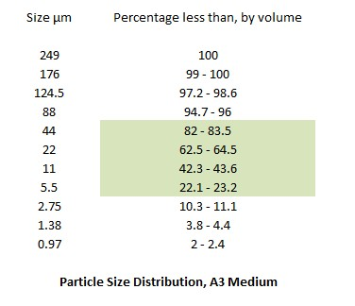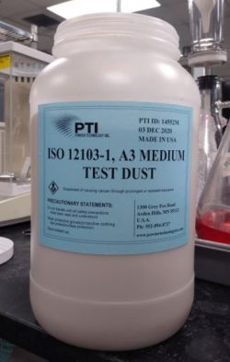

(Fig 1) ISO 12103 test dust, A3 Medium

The sizes highlighted in green approximate the typical 4 to 40µm range of a filter test conducted per ISO 4548-12. A system can be calibrated to report additional efficiencies for the large particles, but there's not much point, as all the decent oil filters are above 95% cumulative efficiency (ß40=20) at 40µm. Particles at the small end of the range can be detected with ICP spectrographic analysis.

Roughly 90% of the world's filter test installations are built by Bonavista Technologies, in Tulsa OK. They're about the size of a small van, and when fully optioned can cost as much as $1 million (Fig 2). The system requires a skilled operator, but like CNC machining centers, automation results in repeatability with high accuracy. How high? I asked an experienced project engineer at Bonavista, who said any user should be able to generate efficiency values with less than 10% variation as compared to any other lab. The best labs will vary by little more than 1%. Those estimates are matched by the round robin exercises outlined in ISO 4548-12 itself. Although it's possible to introduce variations with different batches of test dust, dilution ratios, and counter calibrations, they are remarkably small.

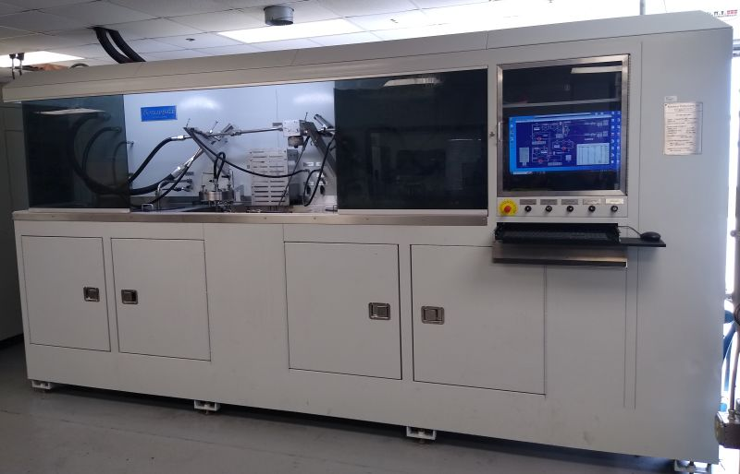

(Fig 2) Filter test installation

The ISO 4548-12 multi-pass method is conceptually simple. A dilution system continuously injects contaminant into fluid loop at a carefully metered rate. The fluid in the loop (MIL-H-5606, i.e. Aeroshell 4) is dosed with an anti-static and held at 100F to control viscosity. A constant displacement pump moves it around the loop at 6 gallons per minute, similar to our small flat engines at cruise RPM. A laser-based device (most commonly a Pamas 4132) records particle count and size before the flow enters the filter. Downstream, an identical device counts and sizes the particles which passed through the filter. The flow continues around the loop, where it picks up more contaminant. As the test progresses, the filter accumulates particles, which hinder flow. The differential pressure, measured across the element, slowly rises, but as the element nears capacity, the rate of rise steepens significantly. The test is terminated at some specified deltaP, typically selected to remain well below the opening pressure of the filter's bypass valve. The total capacity of the filter is recorded in grams.

Five filters were selected as representative of current EAB use. They were a Champion 48108-1, a Tempest 48108-2, a Wix 51515 auto filter, a K&P S-15 reusable screen filter, and a Challenger 48108C screen filter. The Champion and Tempest filters were obtained from Aircraft Spruce stock in mid January of 2024. The Wix was purchased at a local auto parts store. The K&P and Challenger were new, uninstalled units donated by Jon Friedemann and Phil Sprang. All were run using the parameters spelled out in ISO 4548-12. Each run was terminated when the filter collected enough contaminant to push the element pressure drop to 10 psig above clean.

(Fig 3) is a summary table in ISO 4548-12 format. We'll use the Champion as an example. Efficiency was recorded at 10 minute intervals until termination at 110 minutes, then averaged. Recall "cumulative" means "this size and larger", so the filter captured 4% of all particles 5µm and larger, 61% of all particles 25µm and larger, and 99% of all particles 40µm and larger. (Fig 9) presents the same efficiency results in graphical format.

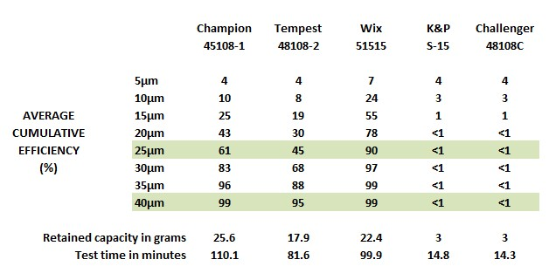

(Fig 3A) Summary table, cumulative filter efficiency, average clean to fully saturated per ISO 4548-12

Sharp readers will note neither Champion or Tempest met the 75% at 25µm standard of ARP 1400B. To be fair, 1400B specifies 8 psig termination, not 10, and efficiency tends downward as the filter collects more trash. An average based on 8 psig termination would look a little better, but we rarely collect even that much dirt. A new, cleanChampion meets the standard, and a new Tempest gets close (Fig 3B). If you like 'em, use 'em.

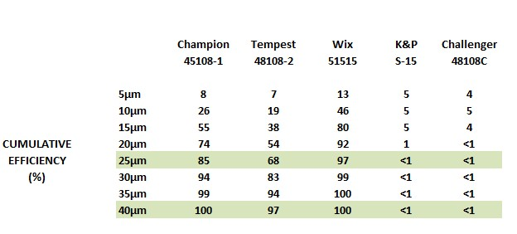

(Fig 3B) Cumulative filtration, near new.

Retained capacity is more than adquate with the Champion, Tempest or Wix. None rise above 8 psig until well beyond the 15 gram minimum of ARP 1400B.

The Wix demonstrated better efficiency than the Champion or Tempest. However, be aware 1400B's structural standards don't apply to auto filters. For example, Wix lists the 51515's burst pressure at 290 psi, well below the 500 psi of the aircraft brands. Although unlikely to be an issue for a user running multigrade aviation oil in a temperate climate, 50W and low temperature could change the picture. Minor caveats include the lack of an installation nut, no safety wire provision, and users must add a nipple if installing on a xx110 application.

As noted, this particular Wix was selected merely because it was representative of a respected auto filter. Quite a few EAB owners already fly it as a replacement for a 48108. However, it's certainly not the only choice, and readers should not consider its appearance here as a recommendation. Readers who wish to go full auto might also consider offerings from Baldwin, Donaldson, and Purolator, which like Wix is a Mann+Hummel brand. Read those specification sheets!

The test values recorded for the two screen filters are not misprints. A woven screen offers one opening size across its entire face, defined by the wire size and weave pattern. As such, they tend to act as a sieve or separator, allowing essentially all contaminants smaller than the openings to pass, while blocking all contaminants larger than the openings. This is distinctly different from a depth media, a comparatively thick fiber mat with a limitless variety of pore sizes and flow paths. While a screen tends to sort particles in an absolute pass/no-pass manner, a depth media stops *some* percentage of *all* particle sizes.

At a glance, the report raised two obvious questions. On their website, K&P states *"The medical grade stainless steel cloth that we use is consistent across the entire media surface and is rated at 35 microns..",* while Challenger, on their own website, states *" The medical grade, stainless steel mesh used in our filter is rated at 22 microns".* So why did neither screen register efficiency in the 20 to 40µm test range? And why the same results for both?

Fig 4 and Fig 5 are photos taken at 10x magnification. These and others identify both the screens as 50x250 plain Dutch weave, a widely used industrial cloth.

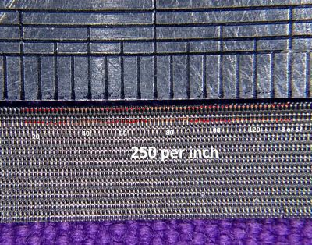

(Fig 4) Weft count

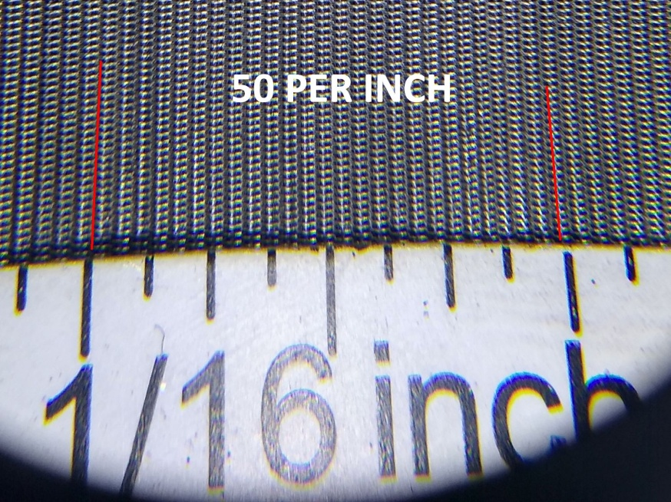

(Fig 5) Warp count

In addition to warp and weft counts, the cloth can be further identified by measuring the wire diameters (0.0055" and 0.0045" respectively), and a woven thickness of 0.012". A key visible characteristic is the widely spaced warp wires and the tightly compressed weft wires. When viewed perpendicular to the surface, there are no visible apertures. Flow passes through the weave at an angle, as seen in (Fig 6).

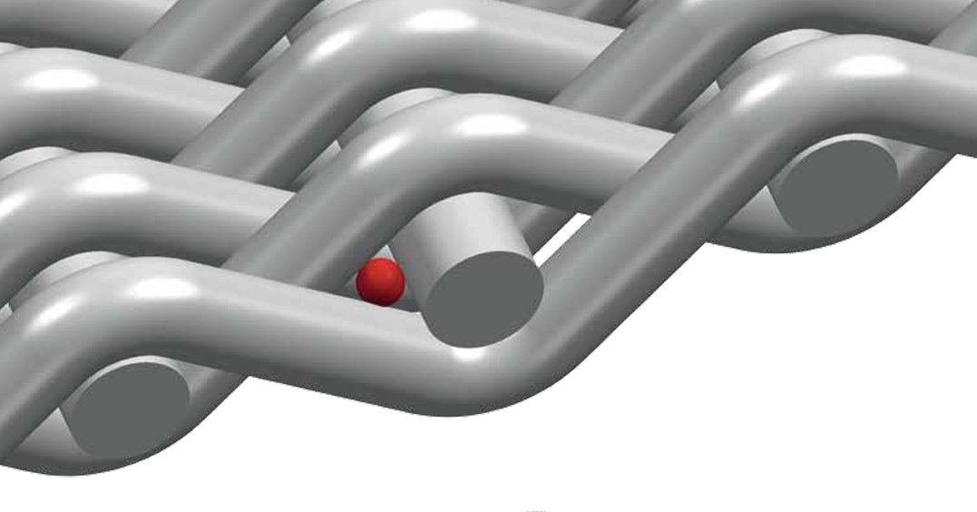

(Fig 6) Absolute aperture, plain Dutch weave (image courtesy W. S. Tyler)

To ensure accuracy, the samples were sent to a professional wire mesh calibration lab for a second opinion. The lab confirmed near identical counts for the S-15 (51x252) and Challenger (50x256), as well as the fabric type and typical performance.

So what does it mean? The widely recognized absolute micron rating for this fabric is approximately 60µm, with a reported range of 56µm to 64µm absolute, depending on source. The reported *nominal* rating appears to be around 40µm. These values align with the demonstrated ISO 4548-12 performance. The screens are too coarse to catch much of anything within a specified test range ending at 40µm. Instead, they captured only the largest particles in the A3 size distribution. Continuous contaminant injection combined with limited removal eventually raises the circulating concentration to a level beyond the capability of the particle counters.

Note the retained capacity and test time. The screens clogged at 3 grams, well below the 15 gram requirement of ARP 1400B. As they clogged, the deltaP ramped up sharply, rather than exhibiting the more gradual rise of a depth media. It's a characteristic of screen filtration called *blinding*, the obstruction of the openings in the filter, which are uniform and limited in number. When operating in a constant pressure system, blinding generally results in the formation of a filter cake and a drop in flow. However, when operating downstream of a constant displacement pump (i.e. an engine oil pump), the pressure must spike.

The screens did offer less clean pressure drop, a detail often quoted in their favor. However, here it is limited, and doesn't last long. There simply isn't enough media area. (Fig 7) is a visual comparison of a Champion element and a Challenger element, hung together on the shop door. (Fig 8) is a summary of pressure drop across the filter elements vs circulated contaminant.

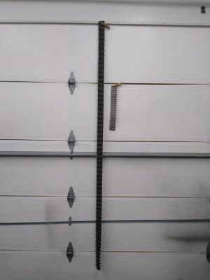

(Fig 7) Champion element (left), Challenger element (right)

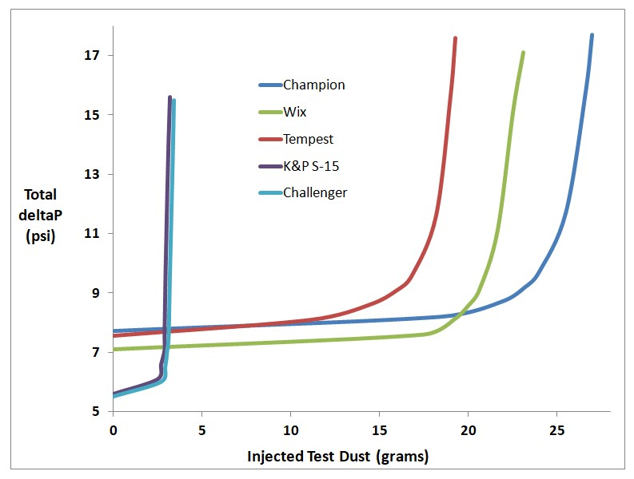

(Fig 8) Total filter pressure loss vs injected A3 Medium contaminant

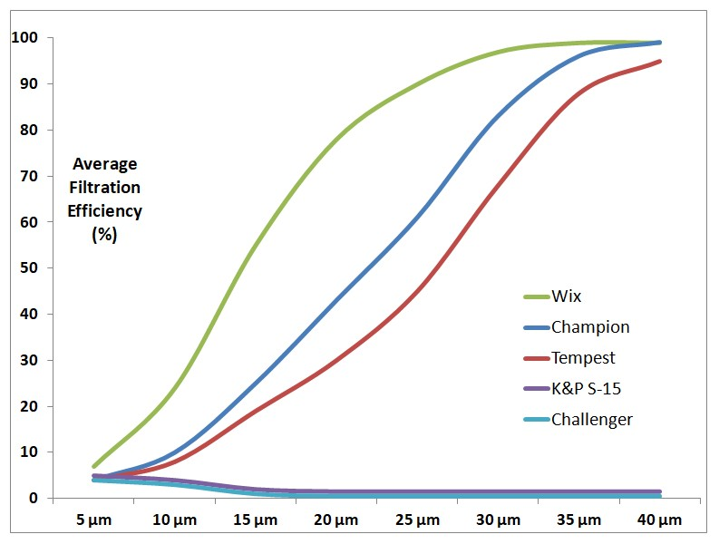

(Fig 9 Cumulative average filtration efficiency, all filters

**So What Is Good Enough?**

Although reference literature clearly shows high efficiency oil filtration significantly reduces wear, the practical benefit depends on the operating environment. Dirty air, sand on the ramp, maybe a little rust? Run the best filter you can find. However, given minimal airborne dust and limited corrosion, our engines do fine with limited filtration. Many make TBO with nothing more than a strainer screen. It catches the big stuff, and it buys time when things go wrong. The 25 hour oil change removes the small particles.

Increasing the change interval requires better fine filtration, as oil alone can't carry the dirt load. In 1975, when ARP 1400B was first adopted, spin-on filters were only 20 years into general acceptance on new cars. The 1400B standard of 75% @ 25µm and 90% at 40µm was state of the art. It allowed aircraft oil change intervals to extend to the automotive standard of the time, about 2500 miles for "severe use", 50 hours at 50 mph.

Our next culture shift is on the way. Lycoming Service Letter L270 already approves 100 hour oil changes with continuous use of an approved unleaded fuel, after the initial 50 hour change. The interesting detail is the filter requirement, which remains at 50 hours. That too will change, when the aircraft industry adopts synthetic filter media...eventually.

DH

END OF MAIN ARTICLE

**Sidebar 1**

**The Standards**

We live on a connected planet. Although national preferences remain, worldwide technical exchange requires common standards, the codified consensus of experts in a particular field. Standards organizations provide the methodology to create and publish carefully defined agreements. Without them, standards are *de facto*, i.e. generally accepted, however imprecise. Consider the cubit, a ancient practical measure. Almost everyone had a forearm or two, even if they were not all the same.

There is no limit on the number of standards organizations, given they form to underpin each new area of technology. The three largest are the International Organization for Standardization (ISO), the International Electrotechnical Commission (IEC), and the International Telecommunication Union (ITU). All are based in Geneva. In addition, there are dozens of regional and national organizations. The relationships are complex, but all tend to adopt the work of the others when appropriate.

The standard specific to piston aviation filters is SAE ARP 1400B. This Aviation Recommended Practice, first published in 1975, was created by a committee formed of representatives from engine manufacturers, filter suppliers, and other stakeholders. The most recent edition was published in 2000, and is again due for review this year.

In addition to construction requirements, ARP 1400B states filtration efficiency and contaminant capacity shall be measured using the SAE J1858 multi-pass method. That particular SAE standard was canceled in 2002. It was superseded by ISO 4548-12, the recognized international standard for oil filter test.

Not surprisingly, there are other incorporations. Among them are ISO 12103-1, which defines the test dust ("A3 Medium"), a carefully processed powder made from sand and rock harvested in Arizona. A second, MIL-H-5606, is familiar to every A&P. GA uses it as brake fluid, but here it's the specified test oil, chosen because it is a uniform product available worldwide.

**Sidebar 2**

**Sponsorship**

ISO 4548-12 filtration tests are expensive. An ISO 4548-12 test bench has a base price upward of $300,000, and the engineers who run them are not paid minimum wage. Typical quotes are $1000 to $2000 per oil filter for depth media types with moderate run times to saturation.

This particular set of five tests was made possible by the generous corporate sponsorship of Rhonda Barrett at Barrett Precision Engines (bpaengines.com), and Eric Anderson at CamGuard (aslcamguard.com). Their support was combined with cash and filters from more than 40 individual Vans RV owners, organized online at *vansairforce.net*. The entire sponsor list can be viewed at *tinyurl.com/VansAirForceFilterDonors*.

Thank you everyone. It couldn't have been done without you.

**Sidebar 3**

**Spectrographic Oil Analysis**

An ICP spectrogram is an excellent tool, but it's important to understand the limitations inherent in the technology. "ICP" means "inductive coupled plasma". A prepared oil sample is injected into argon plasma, where very high temperature ionizes the atoms, generating light. A prism separates the light into a spectrum, much like a rainbow. The frequency at each point in the spectrum corresponds to an individual element, which allows identifying the various elements in the sample.

The practical limitation involves the *size* of the particles in the sample. A typical ICP spectrometer cannot effectively ionize particles above a certain size. The technical limitation is often given as 3µm, but 10µm or so is generally accepted as practical. Above 15µm, an ICP spectrometer is blind.

In practice, it means an oil sample can include a significant quantity of larger particles which remain undetected until mechanically reduced to something under the detection limit. A low value on an ICP spectro report does not indicate the actual quantity of material in suspension. It's why oil monitoring reports are best used to track trends, not actual contamination levels.

**Sidebar 4**

**Disclaimer and Permission**

The author is indebted to multiple members of the filtration community, both individual and corporate. Notably they include Southwest Research, Bonavista Technology, Pamas USA, and W.S.Tyler, all highly respected in their fields.

These firms serve the entire industry, and carefully maintain an absolutely non-partisan position. None endorse any particular brand or product, other than their own. Here both author and magazine share their position.

**Sidebar 5**

**Constant Pressure vs Constant Flow**

Fluid systems generally operate at constant pressure, or a constant rate of flow, depending on design goals. A water tower is a good example of a constant pressure system. Gravity generates constant pressure at the upstream side of a restriction. Changing the degree of restriction changes the downstream quantity and pressure, but the upstream pressure remains fundamentally the same.

A constant flow system is typically driven with a positive displacement pump. Gear and gerotor oil pumps are excellent examples. Within the limits of a practical system, changing a restriction causes the upstream pressure to rise, while the flow rate before and after the restriction remains the same.

The fundamental difference explains a detail of filter performance. In a constant pressure system, filter restriction slows the flow rate, while the buildup of captured contaminant *adds* to filtration efficiency. For example, a dirty water filter may slow downstream flow to a trickle, but the water itself will be cleaner.

Things change when we drive the system with a constant displacement pump. Filter restriction causes the upstream pressure to rise. The increased pressure difference between the two sides of the element means more velocity through the remaining microscopic pathways. The increased pressure and velocity tends to wash particles through to the downstream side, so as the filter loads with more and more contaminant, the efficiency goes *down*. It's easily seen in 4548-12 tables. The lesson is clear; a new oil filter works better than one left in service too long.