Flush Rivet Removal – Dan Horton – June 2013
____________________________________________________________

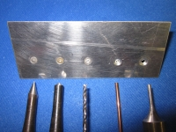 Illustration 1

There can be 10,000 rivets in an aluminum kitplane. Given that many opportunities for error you’ll surely need to replace a few. Don’t worry...removing AN426 flush rivets is easy if you follow these five simple steps.

First, use a sharp prick punch to mark the exact center of the rivet. (Fig1).

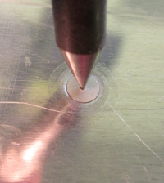 Fig 1

Use a low angle center punch to form a wide dimple for drill guidance (Fig2).

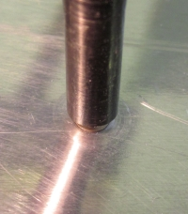 Fig 2

Use a new, sharp drill bit. Drill only to a depth equal to the thickness of the head. NEVER drill all the way through the work. (Fig3).

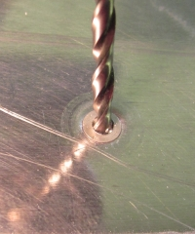 Fig 3

Break off the head using a rod or punch with a sharp squared tip (Fig 4). The tool here is just a short section of scrap welding rod.

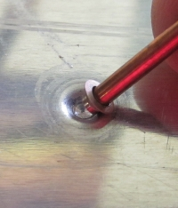 Fig 4

Now use a punch to push out the rivet shank (Fig5). Note the undamaged dimple.

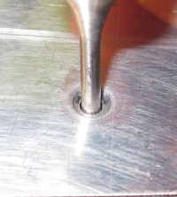 Fig 5

If the workpiece is thin gauge aluminum, the material around the hole may be deformed or bent when you strike the punch.

To eliminate damage drill 0.1875” and 0.250” holes in the end of a spare bucking bar (Fig 6).

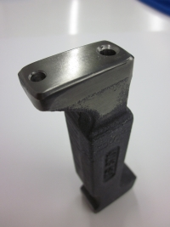 Fig 6

Simply place a suitable hole over the shop head of the rivet before you strike the punch (Fig 7). Given good support the aluminum will not be deformed and the rivet shank will pop right out.

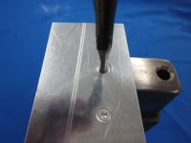 Fig 7

Don’t have enough hands to hold a backup bar, a punch, and a hammer? It doesn’t take much force to pop the rivet shank out of thin material, so try using your spring-loaded prick punch instead.

With a clean, undamaged hole you’re ready to set a new rivet. Have fun!

