COWL PRESSURE AND TEMPERATURE MEASUREMENT

Shopping List

Temperature

(1) National Semiconductor LM34AH-ND Temperature Sensor.

"No lead" (NOPB) version:

http://www.digikey.com/product-detail/en/LM34AH%2FNOPB/LM34AH-ND/182346?cur=USD

Also available in ordinary version, and often on Ebay

(2) Three-conductor wire. 20 or 22 gauge is fine. Shielding not electrically necessary, but shield mesh provides physical protection (armor) in the engine compartment.

(3) Self-adhesive (heat melt glue lined) heat shrink tubing, ¼” and smaller

(4) Good digital voltmeter or voltage panel display

(5) Solder tools and supplies

(6) Fuse and connectors as required (current draw is very low)

Pressure

(1) Thinwall aluminum tubing, 0.1875” OD, 0.014” wall (0.1595” ID), K&S Engineering #1111 or similar. Available in 1foot lengths from McMaster Carr, box of 12, part # 7237K16

(2) Drill bit(s), #60, 0.040” diameter

(3) Flexible connection tubing 1/8” or 5/32” ID, vinyl, tygon, etc. Length as necessary to plumb 4 piccolo tubes above and below engine, then back to cockpit

(4) Two ‘T” fittings for above flexible tubing.

(5) Bulkhead fittings (optional) – Make on lathe from short lengths of threaded rod. Machine barb fitting at each end with ½” of threads in the middle. Bore the center passage as desired. Capture in firewall with a –3 (#10) jamb nut on each side.

(6) Digital manometer – so far we’ve had good results with this unit sourced from China via Ebay. This one is CE brand #2011037035. It's sold under other brand names too.

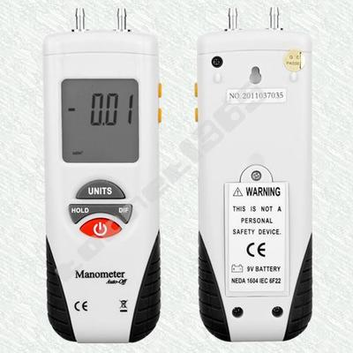

Fabrication and Installation

Temperature

The goal is a temperature probe on the end of a wire, which can be re-located anywhere under the cowl as desired.

The output of the National Semiconductor LM34AH-ND is read with an ordinary hand-held digital multimeter or a digital voltage display. The voltage corresponds to temperature, 10mV = 1 degree F. Example: Meter says 2.5 volts. 2.5V is 2500mV. 2500/10 = 250F. Whatever the meter says, just move the decimal point two spaces to the right and you have temperature.

Datasheet: http://www.ti.com/lit/ds/symlink/lm34.pdf

Only three connections, aircraft power, ground, and sense. Connecting to the avionics bus so the sensor is “on” with flight instruments is fine. Meter negative and probe ground should both be connected to the aircraft single point ground bus.

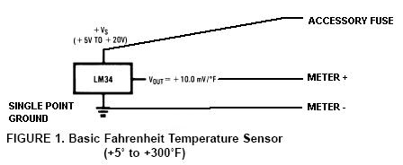

You’ll need a way of routing the probe wire through or around your firewall. Some have run it through the heater duct. Installing a screw-type terminal block on the firewall wired to another screw terminal block in the cockpit is a nice, permanent way to make temporary test connections in the future.

Solder the LM34 to the ends of the three-conductor tefzel shielded aircraft wire. Insulate each lead connection carefully as you go, then cover the entire end with a short length of ¼” adhesive heat shrink. Leave the cap of the LM34’s can uncovered.

The cockpit end will connect to aircraft power and the aircraft ground bus, with the third wire routed to a convenient location for meter connection. Run a single wire from the ground bus to the same location. The latter two wires are for the voltmeter.

You’ll find a great many temperatures of interest, but the primary in this investigation is cooling air exit temperature. The probe is mounted just inside the cowl exit. It is critical to shield the probe from radiant heating, the primary source being the exhaust pipe(s). Fabricate a radiant heat shield as necessary. Make sure the heat shield itself cannot transmit heat to the probe via conduction. Here is a composite (fiberglass) shield structure covered in reflective aluminum tape:

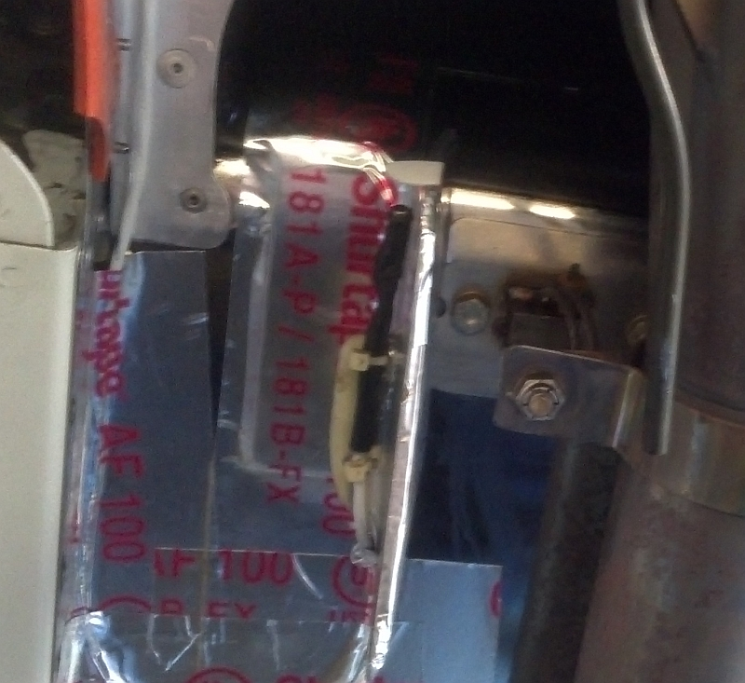

Pressure

Fabricate four piccolo tubes exactly per the drawing. Be gentle; the tubing is thin and fragile. The end (at left below) is simply crimped flat:

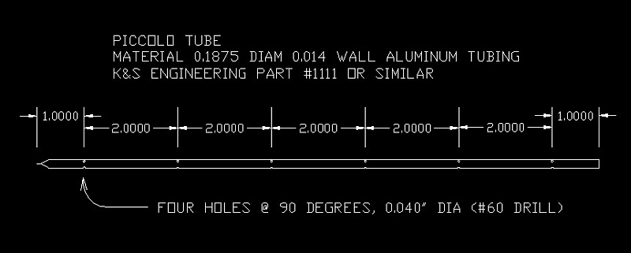

Install two piccolos above the cylinders and two below the cylinders shown:
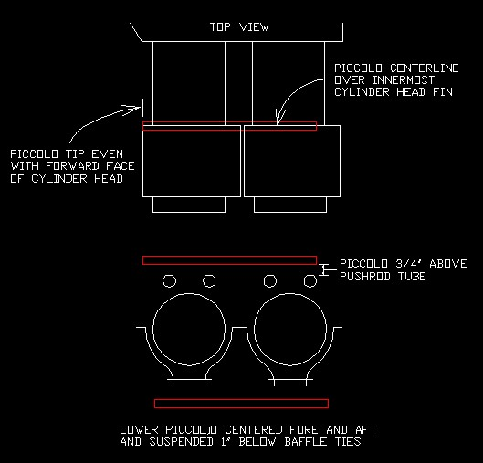

Simple tubing standoffs work well. The upper piccolos can be attached to the fuel injection lines, with appropriate chafe protection:

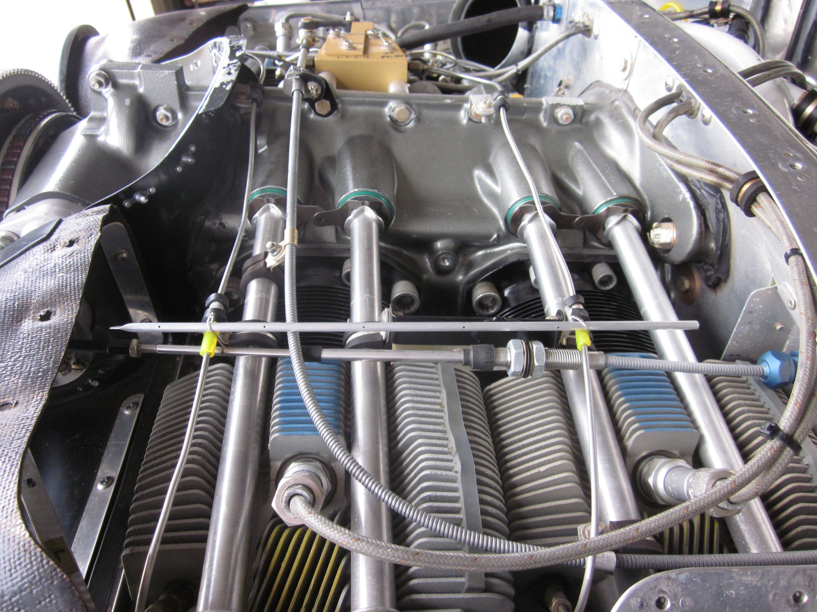

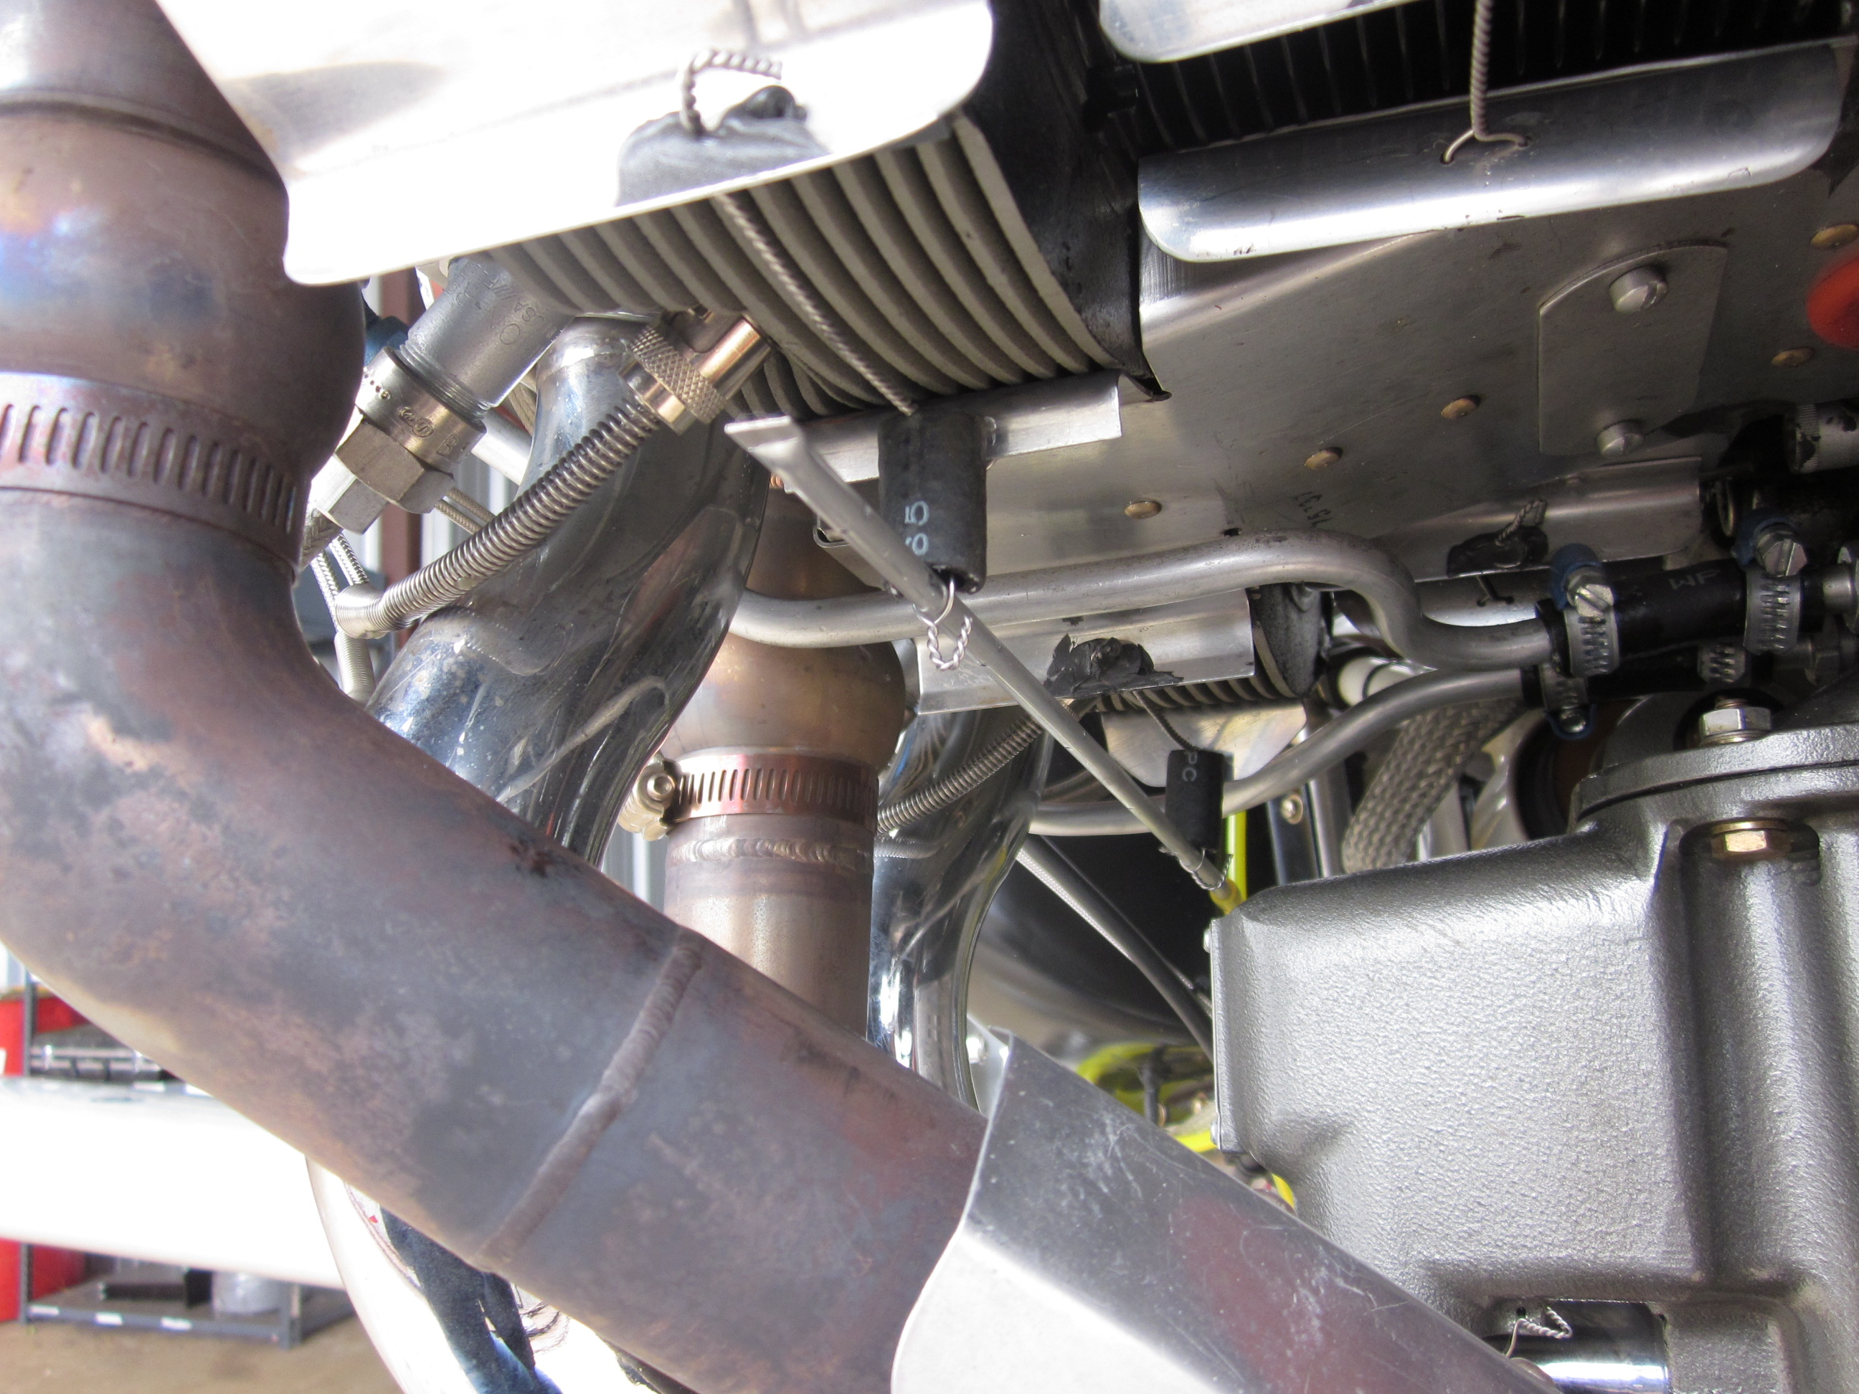
Now plumb the piccolos back to the cockpit. Vinyl tubing seems to work, tygon is more heat resistant. You’ll need the T-fittings to connect the left and right upper piccolos together, and the left and right lower piccolos together. From there the lines are routed through the firewall to the cockpit. The heater duct will work in a pinch, or you can fabricate a more permanent solution, miniature bulkhead fittings made from center-drilled #10 threaded rod.

Mark the lines carefully at the cockpit end, “UPPER” and “LOWER”. You don’t want to confuse them later in flight when you are busy.

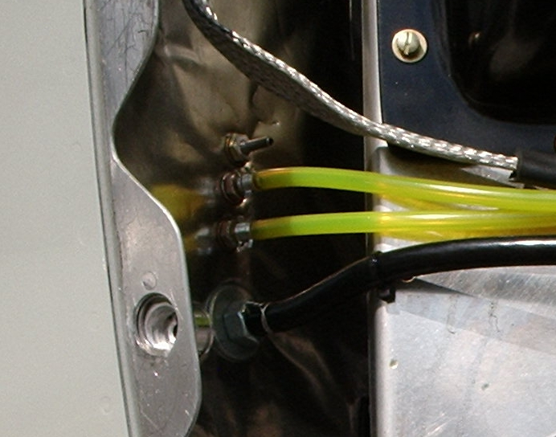

You have one more pressure line to install, a tap into the aircraft static system. Individual methods will vary depending on aircraft static system plumbing details. Most RV’s run a poly tube through the cockpit between the static ports and the instrument panel. Install a quality T-fitting at some handy point in that static line, observing good aircraft practice and good craftsmanship. Connect the T-fitting to one port of the manometer. Keep it connected at all times in order to keep the static system operating as it should. Disconnecting it could cause a false airspeed reading, a dangerous condition on approach to landing. If you remove the connection, carefully plug the static system tap so there is no possible leak.

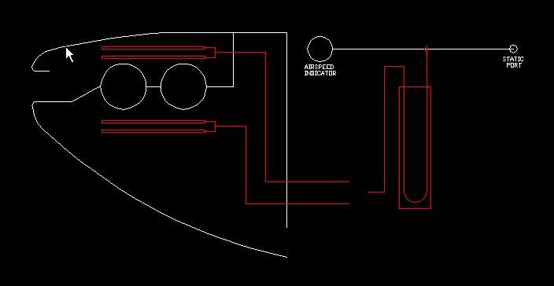

Test Card

Zero the manometer before engine start (see the instructions which came with the instrument).

Climb to 3500 feet pressure altitude, i.e. altimeter reads 3500 when set to 29.92.

Set AP altitude hold mode if you have it.

Set AP to heading mode so you can steer with a heading bug.

Set your GPS to indicate track, or find an EFIS page which indicates track.

Set power for roughly 100 knots indicated, the first target airspeed. It does not need to be exact; anywhere from 95 to 105 will do. The key item is stability; we want a nice stable airspeed, meaning you need a stable altitude hold and a locked throttle quadrant.

Set mixture for about 100 ROP, best power, for heat load to the cylinder heads. Trim when speed stabilizes. Again, no particular exact speed is necessary; just a stable speed which approximates the target speed.

When speed is stable, record GPS groundspeed and GPS track (NOTE: track, not heading).

Turn to a new heading (a 120 degree turn works well). When speed stabilizes, again record GPS groundspeed and GPS track.

Turn to a third heading. When speed stabilizes, again record GPS groundspeed and GPS track. Now record upper plenum pressure, lower plenum pressure, all CHT readings, exit temperature, and OAT.

To make the pressure measurements, simply connect the upper tube to the open manometer port and record the reading. Now swap the lower line for the upper line and again record the reading.

Pay attention to where you are going. The first heading will use some distance because you are setting power. The second goes quickly, just the time it takes for speed to stabilize after the turn. The third heading requires time to stabilize plus time to record the temperature and pressure data.

Now repeat the procedure for the next higher speed, ballpark 120 knots. Then repeat for 140 knots and 160 knots. The airspace required for each three-leg set will increase with increasing speeds; don’t hit anything solid.

When you get home plug the three groundspeeds and tracks for each speed point into the attached NTPS spreadsheet. The result is your true speed for that temperature and pressure data set.

Print the test card / worksheet on the next page and put it on your cockpit clipboard.

DATE__/__ /__ PRESSURE ALT (29.92) __________ OAT_________

100 KNOTS (CALIBRATED ___________________)

GS_____ TRACK______ GS_____ TRACK______ GS_____ TRACK_____

UPPER PLENUM _______ LOWER PLENUM _______

CHT 1______ 2______ 3______ 4______ Exit_______ Oil_______

120 KNOTS (CALIBRATED ___________________)

GS_____ TRACK______ GS_____ TRACK______ GS_____ TRACK_____

UPPER PLENUM _______ LOWER PLENUM _______

CHT 1______ 2______ 3______ 4______ Exit_______ Oil_______

140 KNOTS (CALIBRATED ___________________)

GS_____ TRACK______ GS_____ TRACK______ GS_____ TRACK_____

UPPER PLENUM_______ LOWER PLENUM_______

CHT 1______ 2______ 3______ 4______ Exit_______ Oil_______

160 KNOTS (CALIBRATED ___________________)

GS_____ TRACK______ GS_____ TRACK______ GS_____ TRACK_____

UPPER PLENUM _______ LOWER PLENUM _______

CHT 1______ 2______ 3______ 4______ Exit_______ Oil_______

180 KNOTS (CALIBRATED ___________________)

GS_____ TRACK______ GS_____ TRACK______ GS_____ TRACK_____

UPPER PLENUM _______ LOWER PLENUM _______

CHT 1______ 2______ 3______ 4______ Exit_______ Oil_______

