Mechanical fuel pump spills its guts - David Carr (Digidocs)

It seems to me that the mechanical fuel pump is one of the last alcohol intolerant components left in our fuel systems.
I recently purchased one for science and education and sacrificed it to our noble cause.
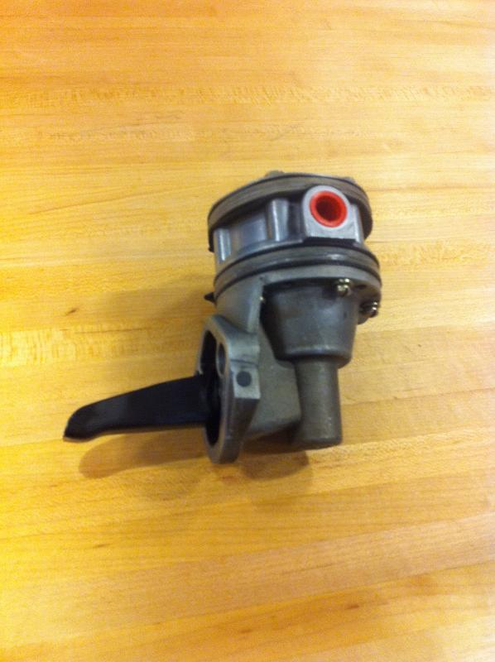
A Lycoming LW-15473 mechanical pump. This is the higher pressure type used with mechanical fuel injection systems.
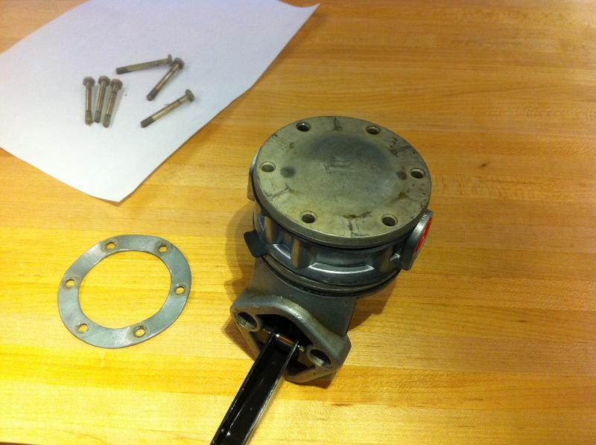
I started by removing the screws from the pulsator cover. The large round disc has a slight wave to it. The screws are tightened to compress it like a spring that applies a semi-constant force the the rest of the stack. Even when torqued, there is about .03" of clearance under the raised portions.

(Dan Note: Screw torque per SB525A is 30 in-lbs. The SB goes on to say "If the spring lock ring is not flat after torquing, the ring is installed upside down".)
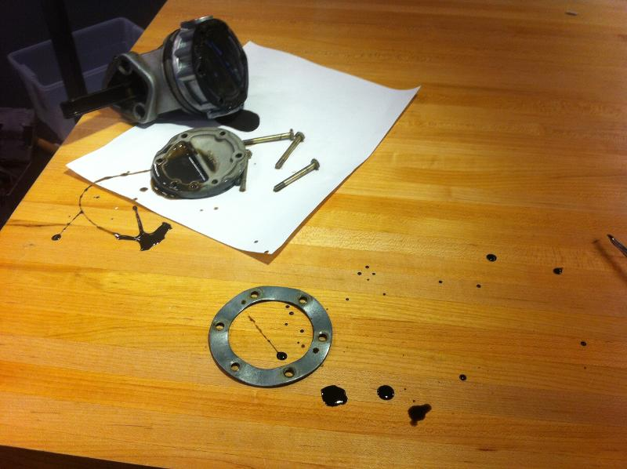
Why is it that gaskets and springs always know when its exactly the most inconvenient time to let go?
The black goo went everywhere except amazingly my pants!
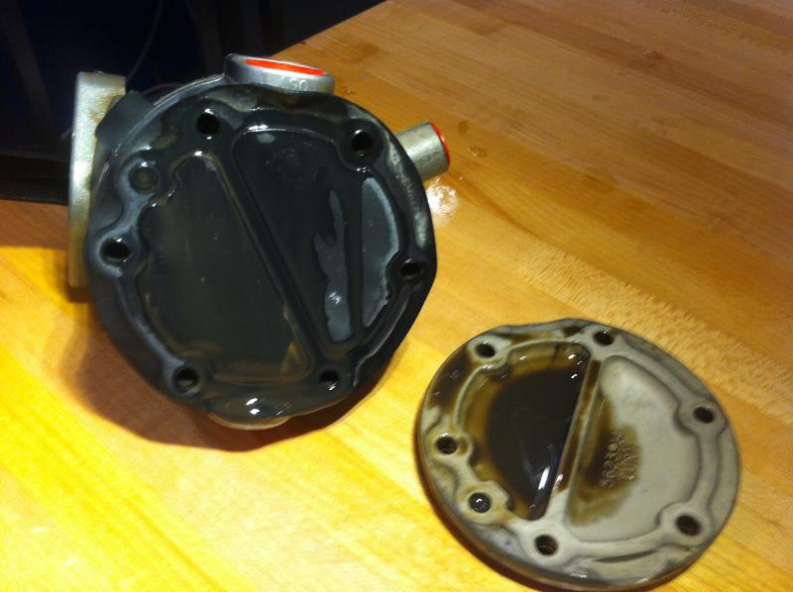
Here is the pulsator cover removed. I'm pretty sure the pulsator diaphragm acts in concert with the sight recesses in the cover to form a sort of pulsation damper.
Maybe it should be called the anti-pulsator?
(Dan Note: Oil in pulsator chamber came from a ruptured oil diaphragm. See photo on page 25 of this Word doc.)
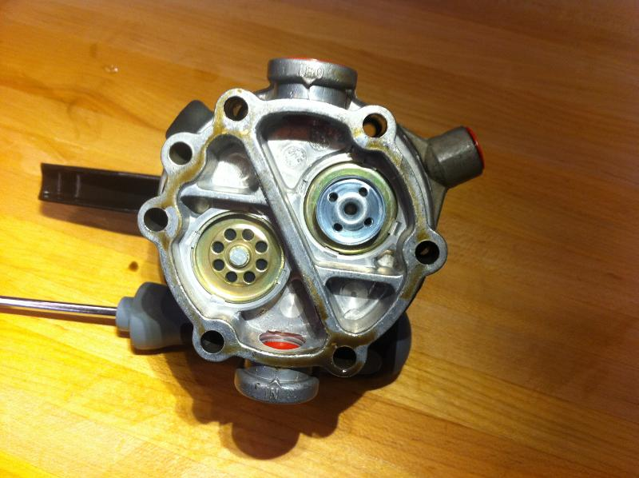
The pulsation diaphragm came off next. Here you can see the inlet (bottom), outlet, and the two check valves.
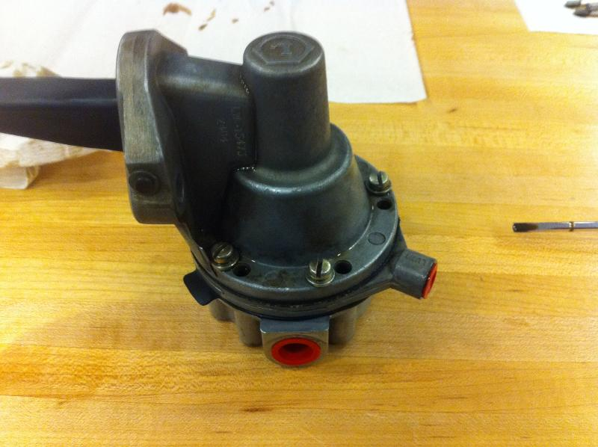
I attacked the screws holding in the main diaphragm next. These pumps have two linked diaphragms. The top one keeps out engine oil and the bottom one pumps the fuel. The space between them is vented to the port at 4 o'clock. If one diaphragm ruptures, you'll get a tell-tale leak out the vent port, but no fuel should get into the oil or vice-versa.
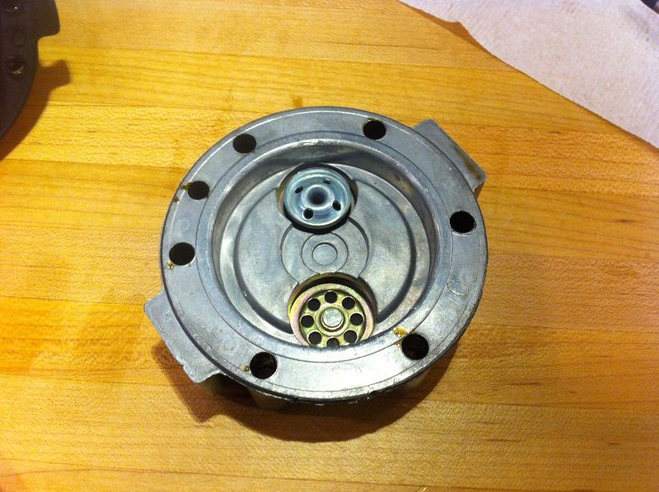
Here's the top of the valve plate. It also serves as the bottom cap for the main diaphragm chamber.
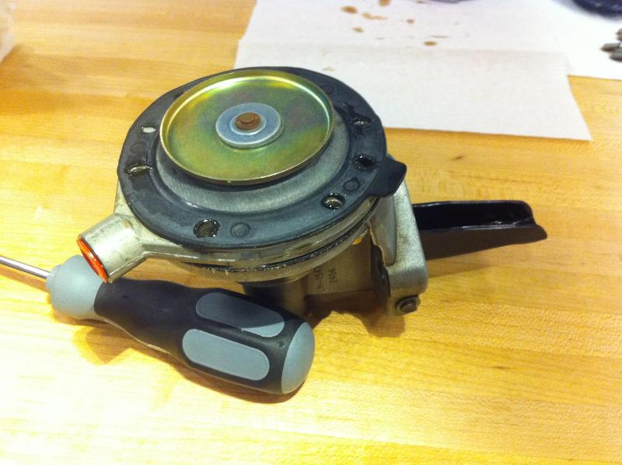
Now we can see our first glimpse of the main diaphragm. Both diaphragms are sandwiched between a set of their own support plates as you can see. The copper colored "rivet" in the center is the end of the rod that connects the two diaphragms and the lever arm.
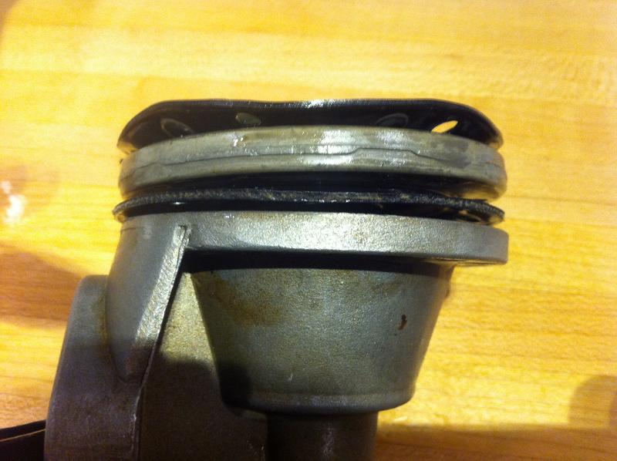
Now that the screws are out, the diaphragm assembly is starting to separate. You can see here that the "oil diaphragm," here at bottom, is significantly stiffer and thicker than the "fuel diaphragm." Both are fabric reinforced rubber.
I'll try to run them through a mass spectrometer soon to identify the exact rubber composition.
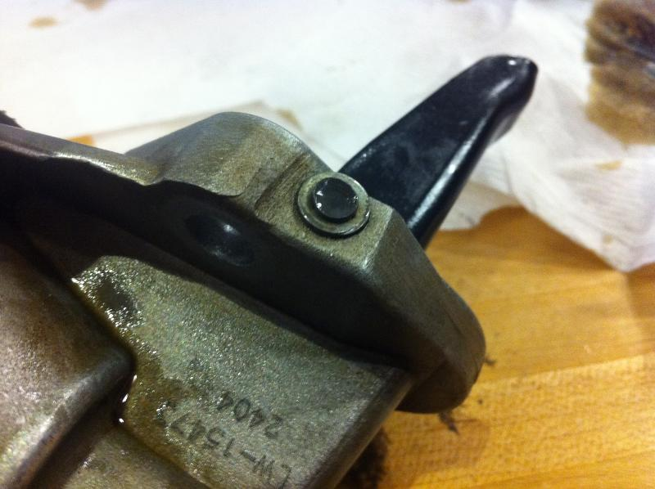
Up until now, the disassembly has been pretty easy. Unfortunately, the rocker arm pivot shaft is now ready to put an end to that. It runs all the way through the body and is retained by a "shop head" on one end.

The battle continues:
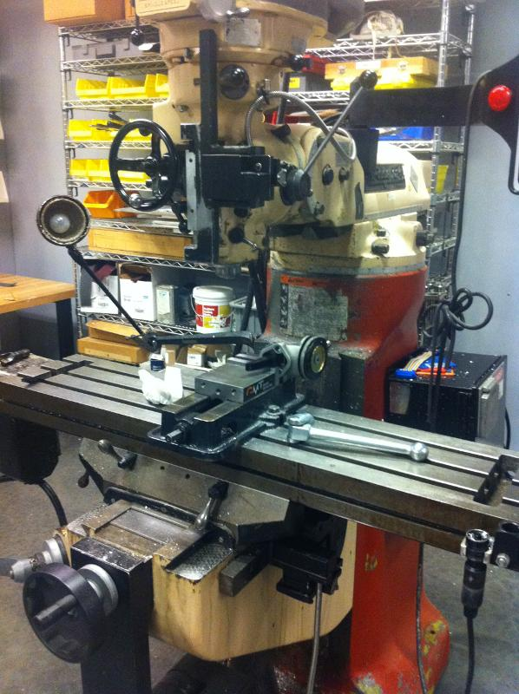
When the only tool you have is a mill, every problem starts to look like a ....?
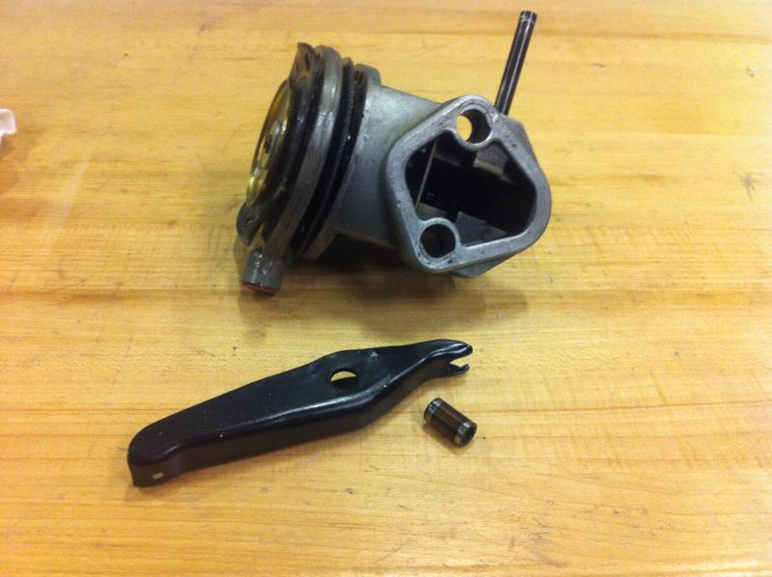
Because this is a family friendly forum, I'll spare you all of the magic words that are required to remove the rocker arm pivot pin.
However, if you ever do face this task just think like a sailor who just dropped the anchor on his toe! Blood is also an excellent lubricant.
Once this pin is clear, just pull firmly on the rocker arm. It and it's pivot bushing will pop out.
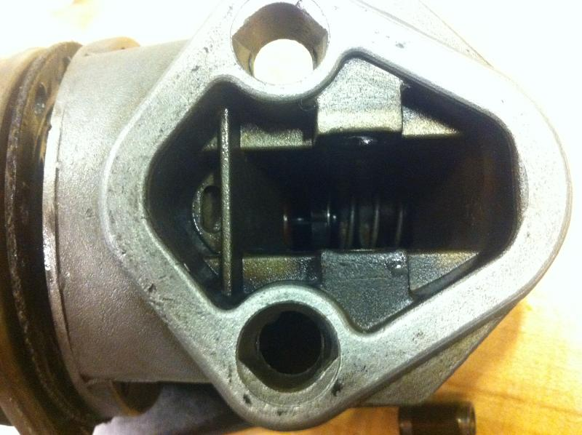
As I said in the first part, it only gets harder from here. This picture represents an hour or so of increasingly desperate attempts to figure out how to remove the diaphragms and the pull rod from the upper housing. I even got so far as to consider cutting a big hole in the side of the casting to get a better look at the mechanism in there.
Turns out all you have to do is pull harder---it just pops right out!
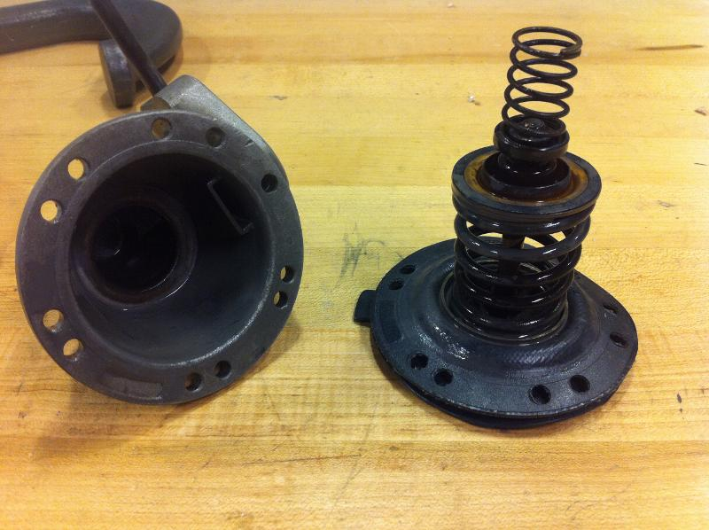
Victory! From bottom to top you can see the two diaphragms, center pull rod, the main spring, the pull rod bushing, a keeper that prevents the pull rod from falling out the bottom, and a smaller spring that keeps the keeper in position.
The inside of the upper housing is on the left.
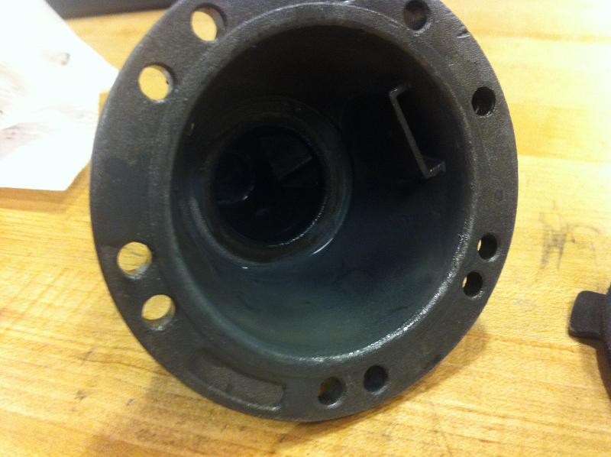
There is an interesting oil channel on the side of the upper housing that connects to a port on inside of the mounting flange.
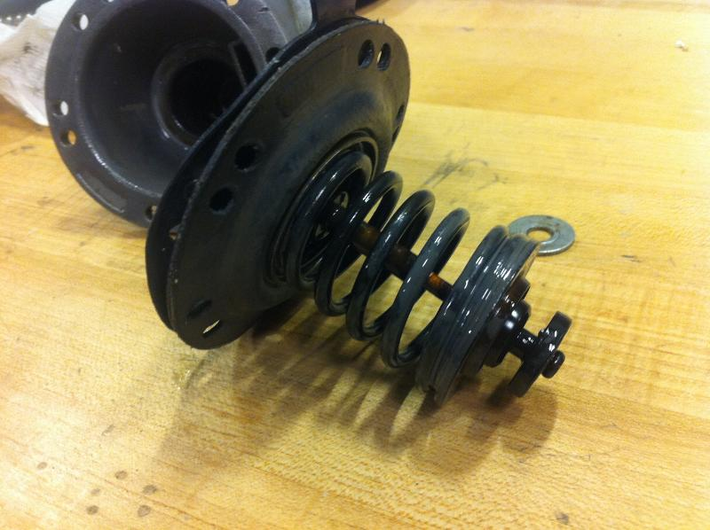
Here's another view of the pull rod assembly.
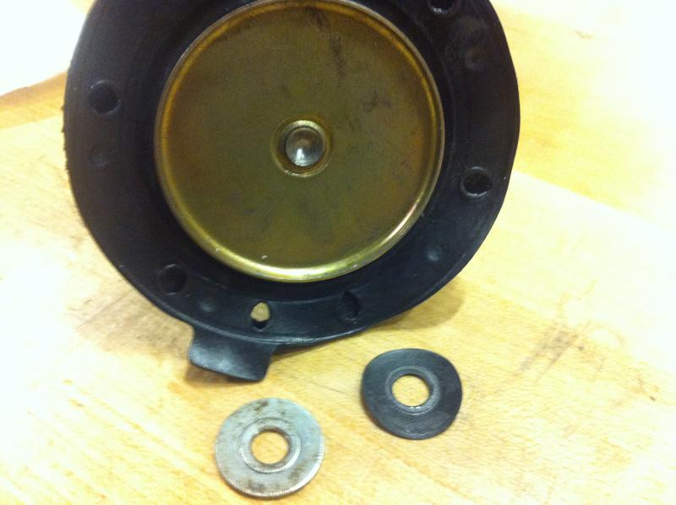
The only way I could see to get the diaphragms off was to drill down the center of the pull rod and liberate them one at a time. The ends of the rod are formed at each end and this "swages on" each metal disk.
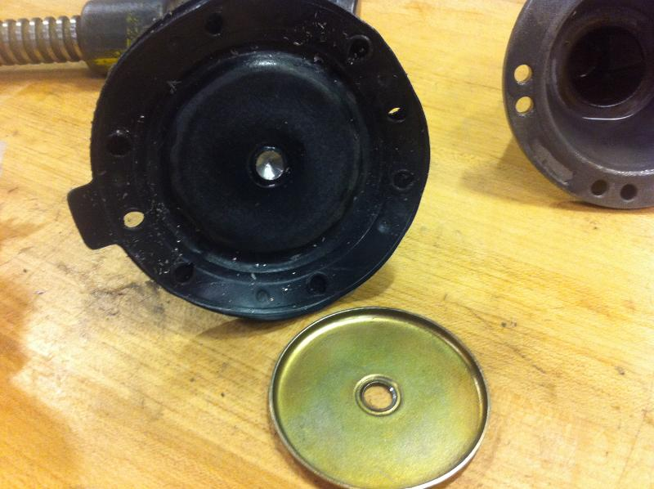
This is the thinner "fuel diaphragm." Both diaphragms have a formed suspension around the edge to give them more travel. Take a look at the edge of a speaker driver and you'll see what I'm referring to.
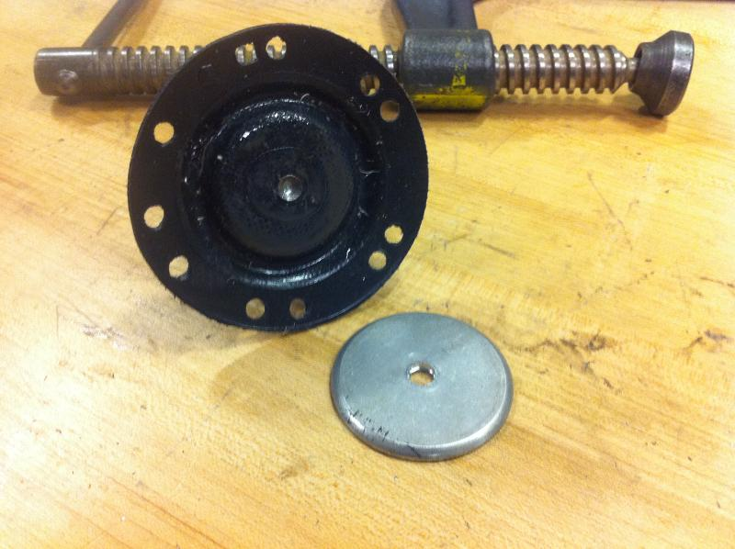
Oil diaphragm.
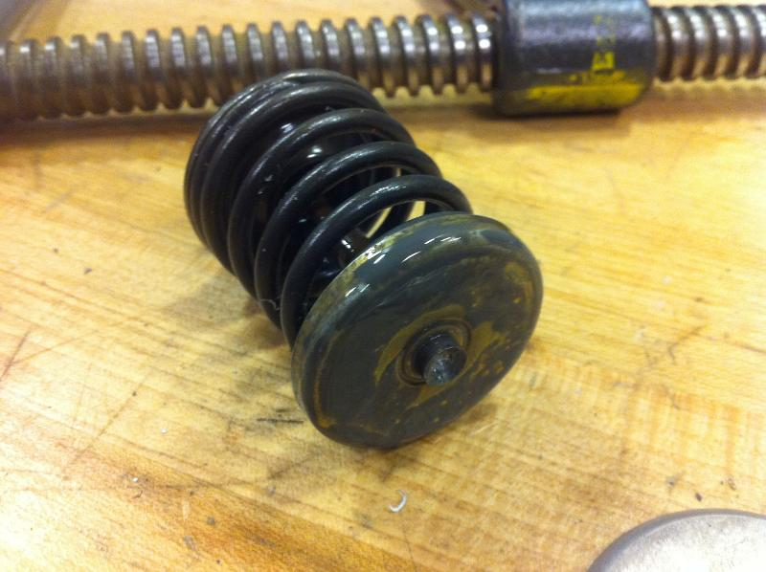
This spring scares me a bit. I can just see it trying to take off my finger as the last plate lets go.
Part 3

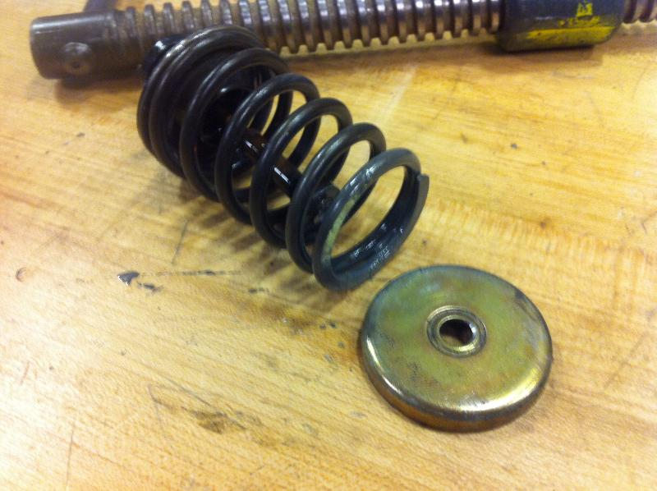
All fingers survived!
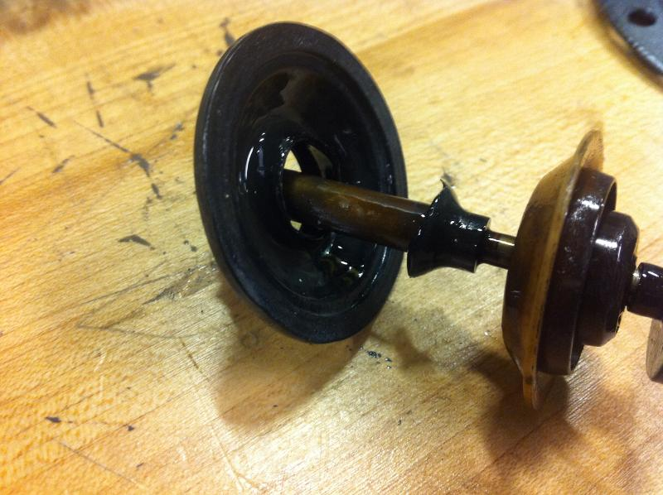
This is the seal/guide assembly attached to the pull rod. I'm not sure whether the hard rubber was broken already or failed sometime during the disassembly process. The diaphragms attach at the left end.
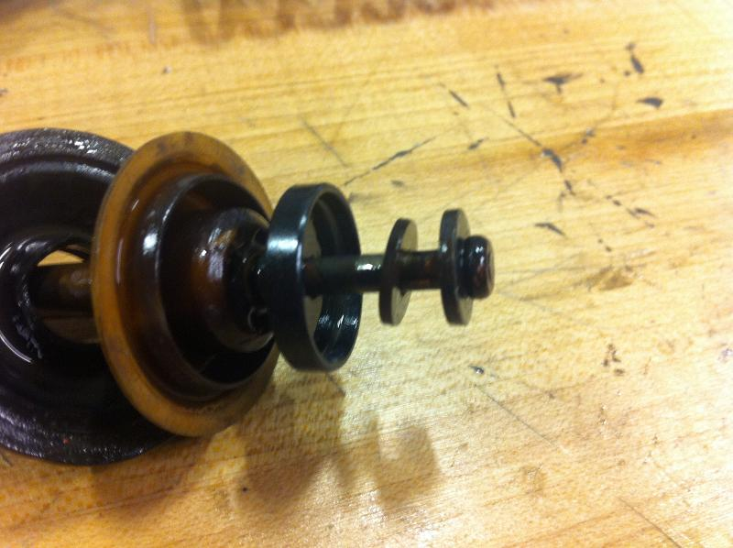
Here's the rocker arm end of the pull rod. While I couldn't see it prior to disassembly, I think the rocker arm goes between the knob on the end and the first disk. The tan plastic piece is the part that snaps into the bottom of the upper housing half.

(Dan note: No, the rocker arm fork goes under the arm return spring cup, the third (larger diameter) disk from the top. The purpose o the lightweight return spring is to make sure there is never any freeplay in the drive lobe/pushrod/rocker arm motion train. See next photo:
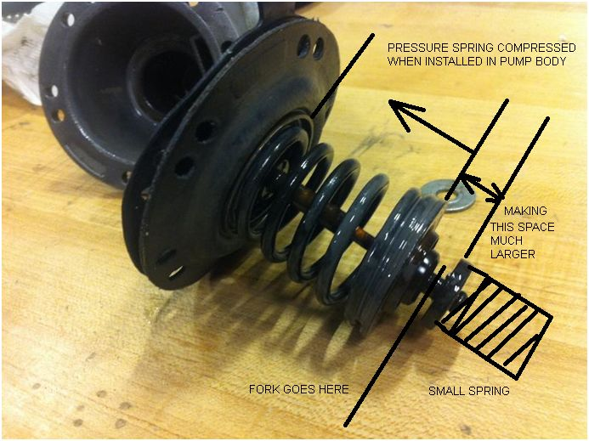

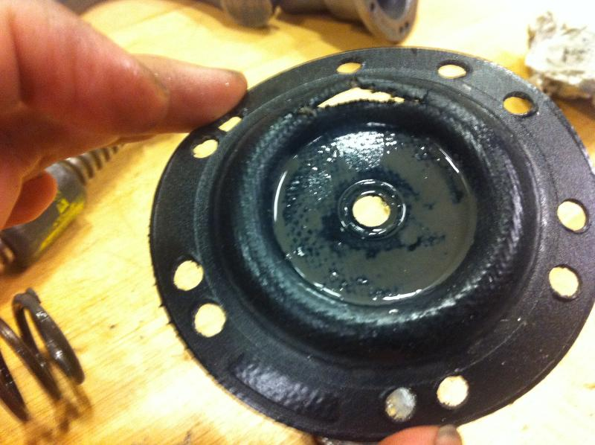
I think we just found out why this pump was leaking oil and removed from service. The "suspension" part of the diaphragm I mentioned earlier is clearly visible too.
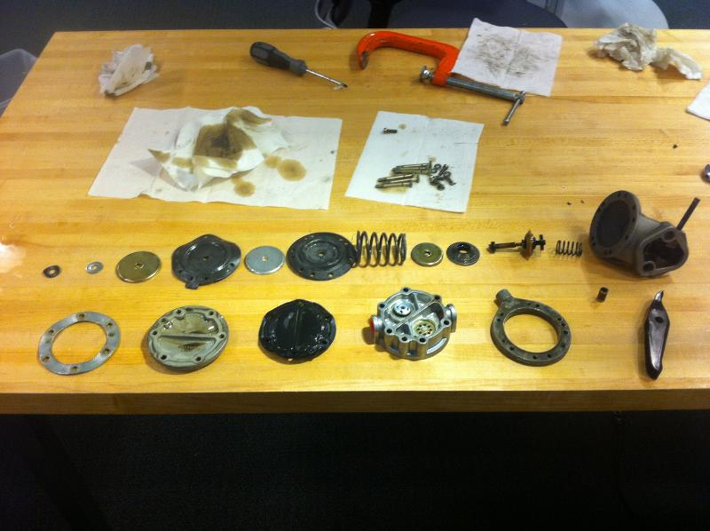
A slow build pump kit?
In the pump, the only rubber components exposed to fuel are the pulsator diaphragm, check valves, and fuel diaphragm. The pulsator diaphragm looks particularly easy to fabricate from a ethanol resistant material, but the valves and diaphragm would probably be a bit more difficult.
This is where I hope the creative minds here at VAF will step in...
Lastly, I hope you enjoyed this little side project. I couldn't find any documentation on these pumps out there, and hopefully this will be as useful as it was fun for me.
Also if you have one of the "old style" fuel pumps that you'd be willing to donate for teardown, that would be interesting as well.
_________________________________________________________________________

Welcome to the mechanical fuel pump guts show---low pressure edition.
Here's a link to the previous high pressure pump disassembly.
Todays victim, a LW-15472 was kindly donated by Mitch Garner and his airpark neighbor who removed it from his airplane. (You'll see why in a minute.)
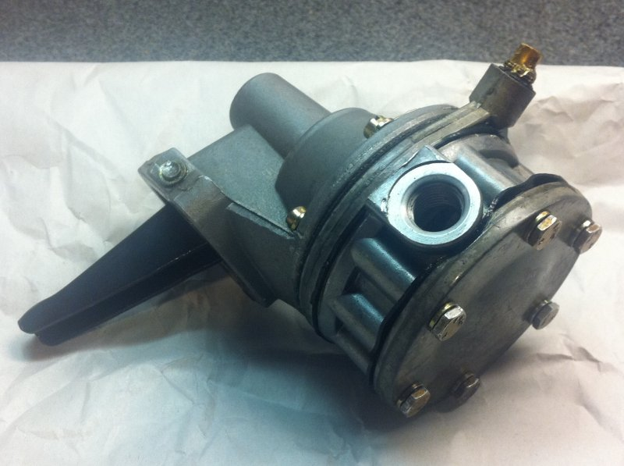
A Lycoming low pressure fuel pump for use in a carburated appliation.
Note here that this pump uses individual lockwashers under each bolt. The previous pump I disassembled, had one large "wavy plate" with holes for each fastener.
I recently came across Lycoming SB 525 which suggests the proper torque for these bolts is 30 in-lbs.
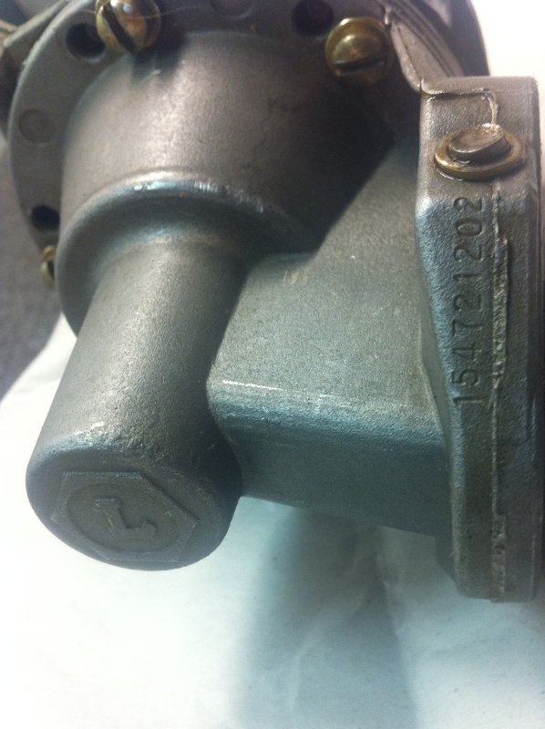
The model number and manufacturing codes. Maybe Dec. 2002?
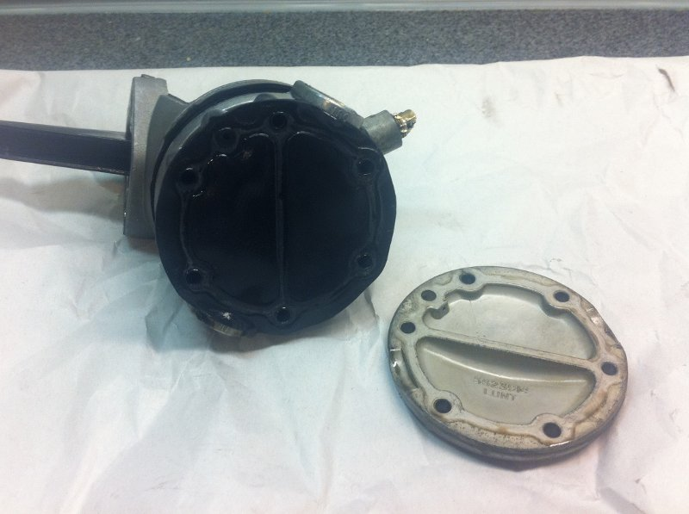
The lower cover comes off. Things look pretty similar to the first pump so far.
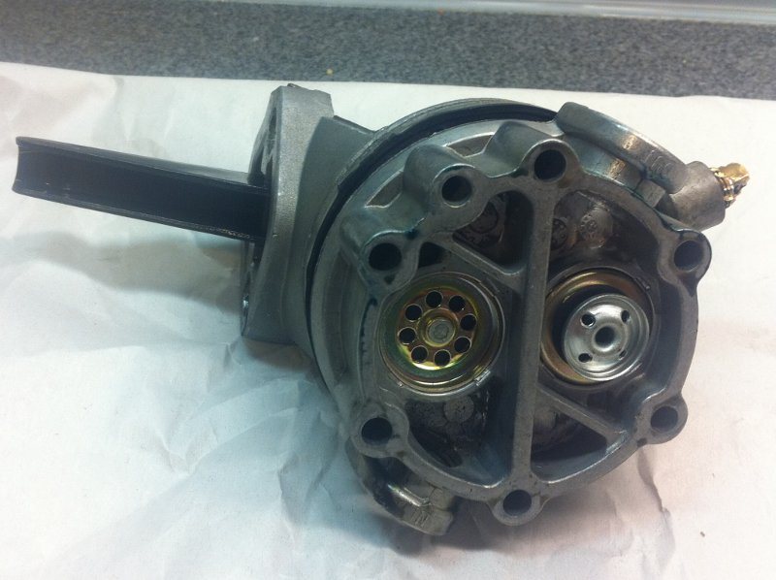
The two flow check valves.
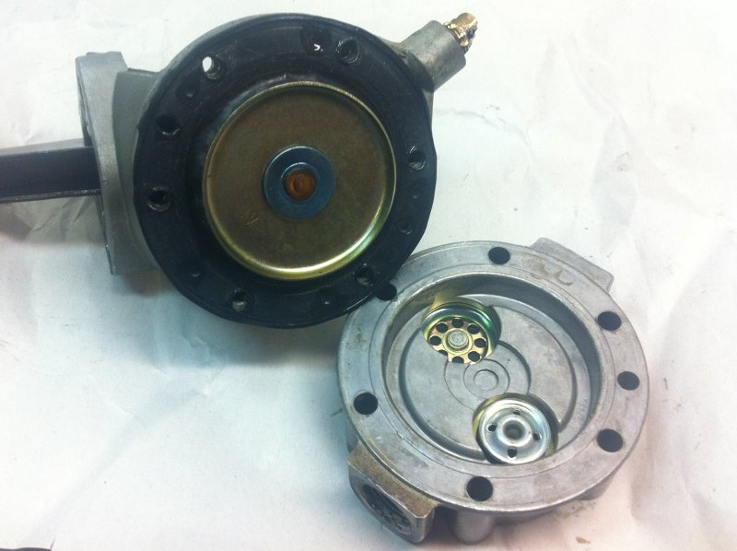
Here's the top of the check valve block and a view of the diaphragms. Everything here looks identical to the high pressure version.
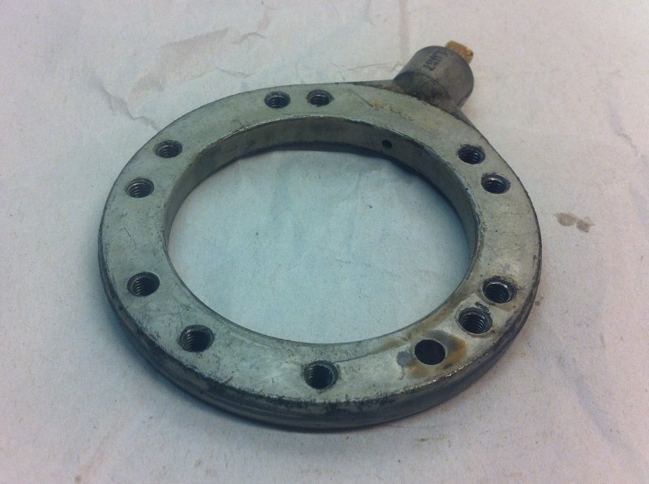
This is the piece of the housing the separates the upper (oil) and lower (fuel) diaphragms. I didn't document it very thoroughly in the previous post, so I thought I'd give it a bit more attention this time. Note the vent outlet at 1 o'clock. It has a brass plug with a hole in it here.
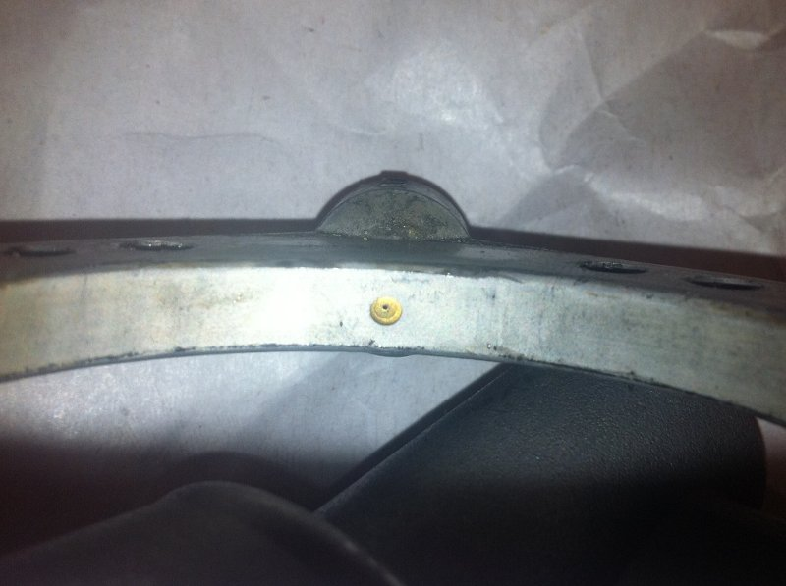
Ordinarily the (vented) space between the diaphragms is just filled with air. However in the event that one diaphragm ruptures, this space will be filled with oil or fuel. The pump will keep working in the near term, but obviously some corrective action is due.
To let you know there is a problem, this inner space is vented hopefully to somewhere where leaking fuel won't cause a major issue and also where you'll notice a leak.
The vent passage out of this space is also fitted with a restrictor to limit the size of the fuel or oil leak. You can see it in this picture pretty clearly. Apparently, in the olden days there wasn't a restrictor in the pump itself and an external one had to be plumbed in. Clearly that is no longer the case.
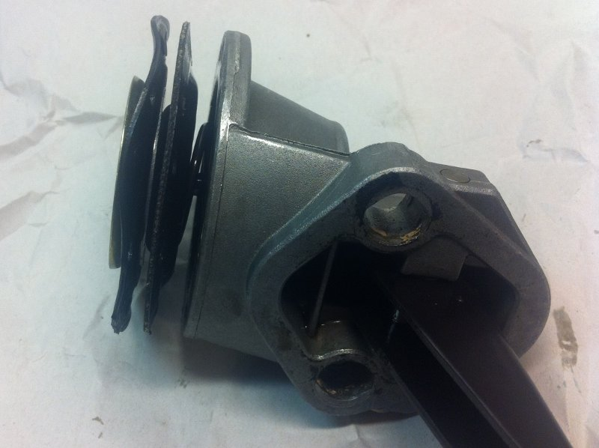
A view of the two diaphragms. They also appear identical to the ones used in the high pressure pump. The thickness varies somewhat, but according to my calipers, the left (fuel)diaphragm is about .045" and the oil diaphragm is about .055".
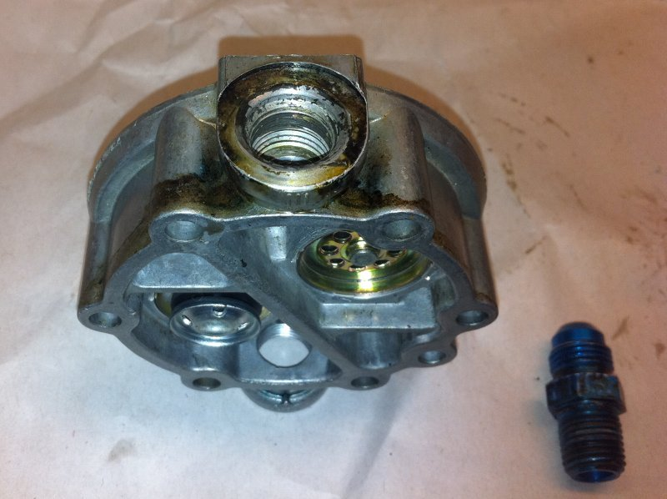
Lastly, as promised---a big fuel leak! According to Mitch, initially the pump was installed with an incorrect fitting, which of course leaked. To fix the leak, the fitting was "super torqued" and then the casting cracked.
So far the only difference that I can find between the low pressure pump and the high pressure pump is the size of the big spring. The high pressure pump spring (shown) is much stiffer than the one installed in the low pressure pump. I cannot depress the high pressure pump lever by hand, but I can do so on the low pressure version.
The way the output pressure in these pumps is regulated is kind of neat. The engine compresses the big spring shown via the pump lever. This pulls the diaphragm up and fuel into the pumping chamber. Then the spring itself supplies all of the force to push the diaphragm back down and the fuel out. Since the spring is responsible for generating all of the "output force", the fuel pressure is in effect limited by the spring strength. If the output were to become blocked, the spring would be unable to force the diaphragm down, and a constant pressure would be produced. Simple and reliable!
Thanks again to Mitch and his neighbor for supplying the pump. Since it appears to be very similar to the previous pump, I decided not to tear the upper section apart (thus ruining it). Instead, I'll reassemble it and perhaps it can be used for ethanol soak/endurance testing on some sort of test rig. Please let me know if you'd like to lead/participate in this part of the experiment.
__________________
RV-10 fuselage in progress.
1944 B-17G - Flying

